***version: 1.1***

CHAPTER

1 Number Systems

*Animation 1.1: Complex Plane*

*Source & Credit:* [*elearn.punjab*](http://elearn.punjab.gov.pk/animations/math/index.html)

1. **Quadratic Equations eLearn.Punjab 1. Quadratic Equations eLearn.Punjab *1. Number Systems eLearn.Punjab 1. Number Systems eLearn.Punjab***

**1.1 Introduction**

In the very beginning, human life was simple. An early ancient herdsman compared sheep (or cattle) of his herd with a pile of stones when the herd left for grazing and again on its return for missing animals. In the earliest systems probably the vertical strokes or bars such as I, II, III, llll etc.. were used for the numbers 1, 2, 3, 4 etc. The symbol “lllll” was used by many people including the ancient Egyptians for the number of ingers of one hand.

Around 5000 B.C, the Egyptians had a number system based on 10. The symbol for 10 and for 100 were used by them. A symbol was repeated as many times as it was needed. For example, the numbers 13 and 324 were symbolized as and respectively. The symbol was interpreted as 100 + 100 +100+10+10+1+1+1 +1. Diferent people invented their own symbols for numbers. But these systems of notations proved to be inadequate with advancement of societies and were discarded. Ultimately the set {1, 2, 3, 4, ...} with base 10 was adopted as the counting set (also called the set of natural numbers). The solution of the equation *x* + 2 = 2 was not possible in the set of natural numbers, So the natural number system was extended to the set of whole numbers. No number in the set of whole numbers W could satisfy the equation *x* + 4 = 2 or *x* + *a* = *b* , if *a* > *b*, and *a*, *b*, UW. The negative integers -1, -2, -3, ... were introduced to form the set of integers Z = {0, ±1, ±2 ,...).



Again the equation of the type 2*x* = 3 or *bx* = *a* where *a*,*b*,UZ and b ≠ 0 had no solution in the set Z, so the numbers of the form

*a*  where *a*,*b*,UZ and *b* ≠ 0, were invented to remove such diiculties. The set

*b*

Q = { *a* I *a*,*b*,UZ / *b* ≠ 0} was named as the set of rational numbers. Still the solution of equations

*b*

such as *x*2 = 2 or *x*2 = *a* (where *a* is not a perfect square) was not possible in the set Q. So the irrational numbers of the type ± 2 or ± *a* where *a* is not a perfect square were introduced. This process of enlargement of the number system ultimately led to the set of real numbers _ = Q~Q’ (Q’ is the set of irrational numbers) which is used most frequently in everyday life.

**1.2 Rational Numbers and Irrational Numbers**

We know that a rational number is a number which can be put in the form *p* where *p, q*

*q*UZ/ *q* ≠ 0. The numbers 16 , 3.7, 4 etc., are rational numbers. 16 can be reduced to the form *p* where *p, q*UZ, and *q* ≠ 0 because 16 = 4 = 4 . *q*1

**Irrational numbers** are those numbers which cannot be put into the form *p* where *q*

*p, q*UZ and *q* ≠ 0. The numbers 2, 3, 7 , 5 are irrational numbers.

5 16

**1.2.1 Decimal Representation of Rational and Irrational Numbers**

1. **Terminating decimals:** A decimal which has only a inite number of digits in its decimal part, is called a terminating decimal. Thus 202.04, 0.0000415, 100000.41237895 are examples of terminating decimals.

Since a terminating decimal can be converted into a common fraction, so every terminating decimal represents a **rational number**.

1. **Recurring Decimals:** This is another type of **rational numbers**. In general, a recurring or periodic decimal is a decimal in which one or more digits repeat indeinitely.

It will be shown (in the chapter on sequences and series) that a recurring decimal can be converted into a common fraction. So **every recurring decimal represents a rational number:**

A non-terminating, non-recurring decimal is a decimal which neither terminates nor it is recurring. It is not possible to convert such a decimal into a common fraction. Thus a **non-terminating, non-recurring decimal represents an irrational number.**

2 3

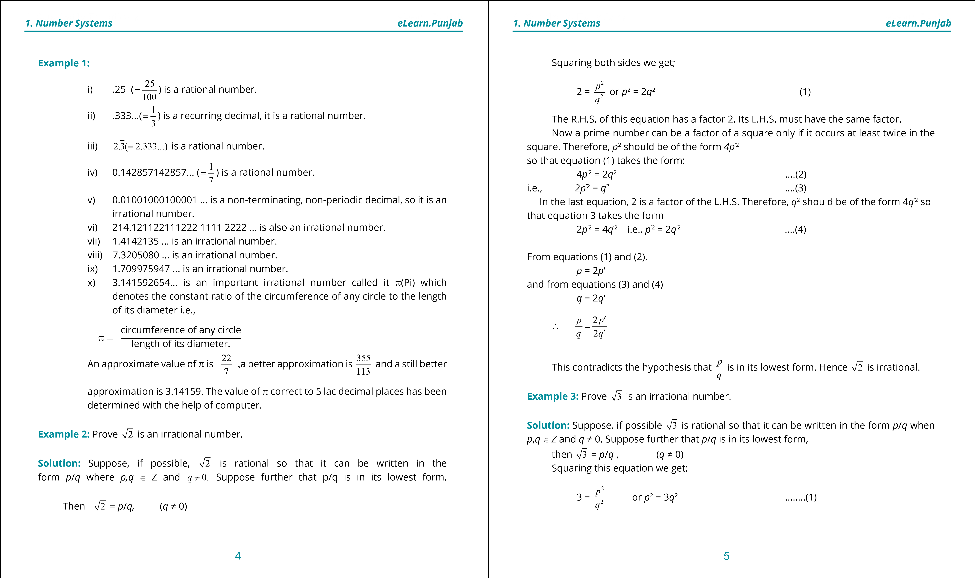

1. **Quadratic Equations eLearn.Punjab 1. Quadratic Equations eLearn.Punjab *1. Number Systems eLearn.Punjab 1. Number Systems eLearn.Punjab***

The R.H.S. of this equation has a factor 3. Its L.H.S. must have the same factor. Now a prime number can be a factor of a square only if it occurs at least twice in the square. Therefore, *p*2 should be of the form 9*p‘2* so that equation (1) takes the form:

9*p*‘2 = 3*q*2 (2) i.e., 3*p*’2 = *q*2 (3)

In the last equation, 3 is a factor of the L.H.S. Therefore, *q*2 should be of the form 9*q*’2 so that equation (3) takes the form

3*p*‘2 = 9*q*2 i.e., *p*’2 = 3*q’*2  (4)

From equations (1) and (2),

*P* = 3*P’*

and from equations (3) and (4) *q* = 3*q’*

∴ *p* = 3*p*′ *q* 3*q*′

This contradicts the hypothesis that *p* is in its lowest form. *q*  Hence 3 is irrational.

**Note:** Using the same method we can prove the irrationality of

5, 7,...., *n* where *n* is any prime number.

**1.3 Properties of Real Numbers**

We are already familiar with the set of real numbers and most of their properties. We now state them in a uniied and systematic manner. Before stating them we give a preliminary deinition.

**Binary Operation:** A binary operation may be deined as a function from A % A into A, but for the present discussion, the following deinition would serve the purpose. A *binary operation* in a set A is a rule usually denoted by * that assigns to any pair of elements of A, taken in a deinite order, another element of A.

Two important binary operations are addition and multiplication in the set of real numbers. Similarly, union and intersection are binary operations on sets which are subsets of the same Universal set.

_ usually denotes the set of real numbers. We assume that two binary operations addition (+) and multiplication (. or x) are deined in _. Following are the properties or laws for real numbers.

**1. Addition Laws: -**

1. **Closure Law of Addition**

[ *a*, bU_, *a* + bU_ ([stands for “for all” )

1. **Associative Law of Addition** [ *a*, b,cU_, *a* + (b + c) = (*a* + b ) + c **iii) Additive Identity**

[ *a*U_, \ 0U_ such that *a* + 0 = 0 + *a* = *a*  (\ stands for “there exists”).

0(read as zero) is called the identity element of addition.

1. **Additive Inverse** [ *a*U_, \ (- *a*)U_ such that *a* + ( - *a* ) = 0 = ( - *a*) + *a*
2. **Commutative Law for Addition**

[ *a*, bU_, *a* + b = b + *a* **2. Multiplication Laws vi) Closure I.aw of Multiplication**

[ *a*, bU_, *a*. bU_ (*a*,b is usually written as *a*b).

**vii) Associative Law for Multiplication**

[ *a*, *b*, *c*U_, *a*(*bc*) = (*ab*)*c* **viii) Multiplicative Identity**

[ *a*U_, \ 1U_ such that *a*.1 = 1.*a* = *a*

1 is called the multiplicative identity of real numbers. **ix) Multiplicative Inverse** [ *a*(≠ 0)U_, \ *a*-1U_ such that *a*.*a*-1 = *a*-1.*a* = 1 (*a*-1 is also written as 1 ).

*a*

**x) Commutative Law of multiplication**

[ *a*, *b*U_, *ab* = *ba*

6 7

**1. Quadratic Equations eLearn.Punjab 1. Quadratic Equations eLearn.Punjab *1. Number Systems eLearn.Punjab 1. Number Systems eLearn.Punjab***

**3. Multiplication** - **Addition Law xi)** [ ***a*, *b*, *c*** U _, *a* (*b* + *c*) = *ab* + *ac* (Distrihutivity of multiplication over addition).

(*a* + *b*)*c* = *ac* + *bc*

In addition to the above properties _ possesses the following properties. i) Order Properties (described below).

ii) Completeness axiom which will be explained in higher classes.

The above properties characterizes _ i.e., only _ possesses all these properties.

Before stating the order axioms we state the properties of equality of numbers. **4. Properties of Equality**

Equality of numbers denoted by “=“ possesses the following properties:- i) Relexive property [ *a*U_, *a* = *a* ii) Symmetric Property [ *a*,*b*U_, *a* = *b* ⇒ *b* = *a*. iii) Transitive Property [ *a*,*b*,*c*U_, *a* = *b*/*b* = *c* ⇒ *a* = *c* iv) Additive Property [ *a*,*b*,*c*U_, *a* = *b* ⇒ *a* + *c* = *b* + *c*

1

1

v) Multiplicative Property [ *a*,*b*,*c*U_, *a* = *b* ⇒ *ac* = *bc* /*ca* = *cb*. vi) Cancellation Property w.r.t. addition

[ *a*,*b*,*c*U_, *a* + *c* = *b* + *c* ⇒ *a* = *b* vii) Cancellation Property w.r.t. Multiplication:

[ *a*,*b*,*c*U_, *ac* = *bc* ⇒ *a* = *b*, *c* ≠ 0

**5. Properties of Ineualities (Order properties )**

1) Trichotomy Property [ *a*,*b*U_ either *a* = *b* or *a* > *b* or *a*< *b* 2) Transitive Property [ *a*,*b*,*c*U_

i) *a* > *b* / *b* > *c* ⇒ *a* > *c* ii) *a* < *b* / *b* < *c* ⇒ *a* < *c*

3) Additive Property: [ *a*,*b*,*c*U_

a) i) *a* > *b* ⇒ *a* + *c* > *b* + *c* b) i) *a* > *b* / *c* > *d* ⇒*a*+*c* > *b*+*d*  ii) *a* < *b* ⇒ *a* + *c* < *b* + *c* ii) *a* < *b* / *c* < *d* ⇒ *a*+*c* < *b*+*d* 4) Multiplicative Properties:

a) [ *a*,*b*,*c*U_ and *c* >0

i) *a* > *b* ⇒ *ac* > *bc* ii) *a* < *b* ⇒ *ac* < *bc*.

b) [ *a*,*b*,*c*U_ and *c* < 0 .

i) *a* > *b* ⇒ *ac* < *bc* ii) *a* < *b* ⇒ *ac* > *bc*

c) [ *a*,*b*,*c*,*d*U_ and *a*,*b*,*c*,*d* are all positive.

i) *a* > *b* / *c* > *d* ⇒ *ac* > *bd*. ii) *a* < *b* / *c* < *d* ⇒ *ac* < *bd*

**Note That:**

1. Any set possessing all the above 11 properties is called a ield.
2. From the multiplicative properties of inequality we conclude that: - If both the sides of an inequality are multiplied by a +ve number, its direction does not change, but multiplication of the two sides by -ve number reverses the direction of the inequality. 3. a and (-*a*) are additive inverses of each other. Since by deinition inverse of -*a* is *a*,

∴ - **(**-***a*)** **=** ***a***

4. The left hand member of the above equation should be read as negative of ‘negative *a*’ and not ‘minus minus *a*’. *5. a* and 1 are the multiplicative inverses of each other. Since by

*a*

deinition inverse of 1 is *a* (i.e., inverse of *a*-1 is *a*), *a*≠0

*a*

∴ (*a*-1)-1 = *a* or = *a*

*a*

**Example 4:** Prove that for any real numbers *a*, *b*

i) *a*.0 = 0 ii) *ab* = 0 ⇒ *a* = 0 *0* *b* = 0 [ *0*stands for “or” ]

**Solution:** i)*a*.0 = *a*[1+ (-1)] (Property of additive inverse)

= *a* (1 -1) (Def. of subtraction)

= *a*.1-*a*.1 (Distributive Law)

= *a* - *a* (Property of multiplicative identity)

= *a* + (-*a*) (Def. of subtraction) = 0 (Property of additive inverse) Thus *a*.0=0. ii)Given that *ab* = 0 (1)

Suppose *a* ≠ 0, then exists

8 9

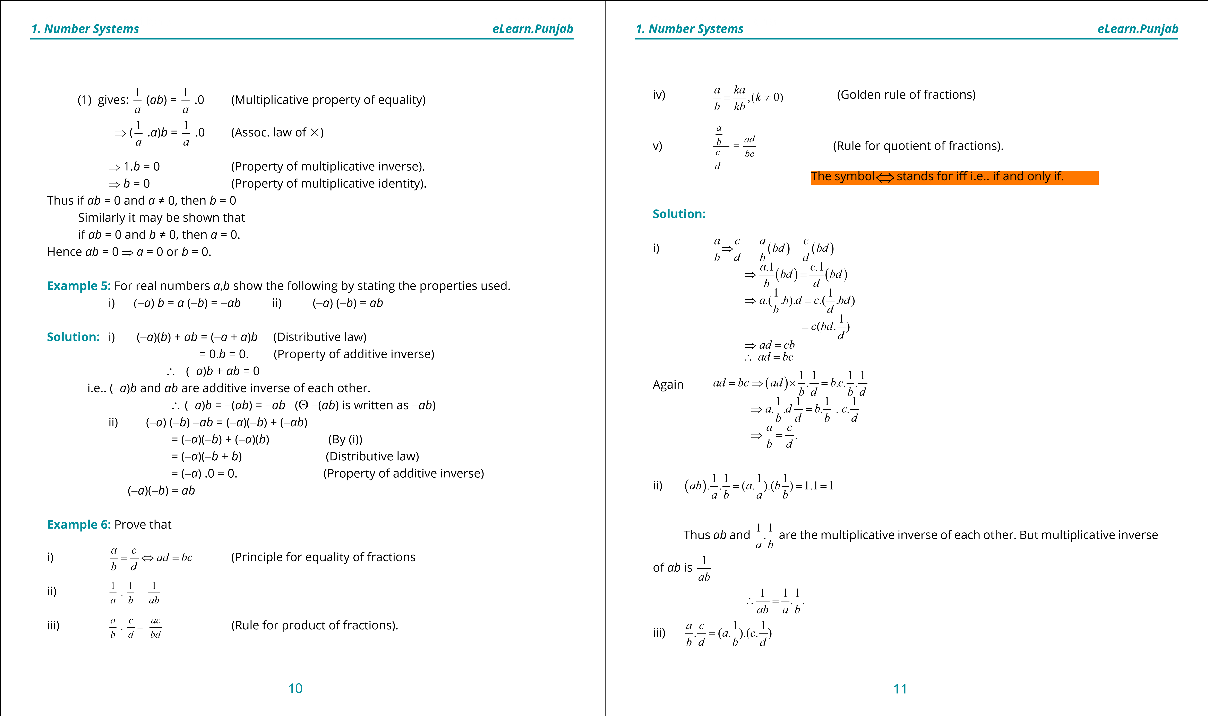

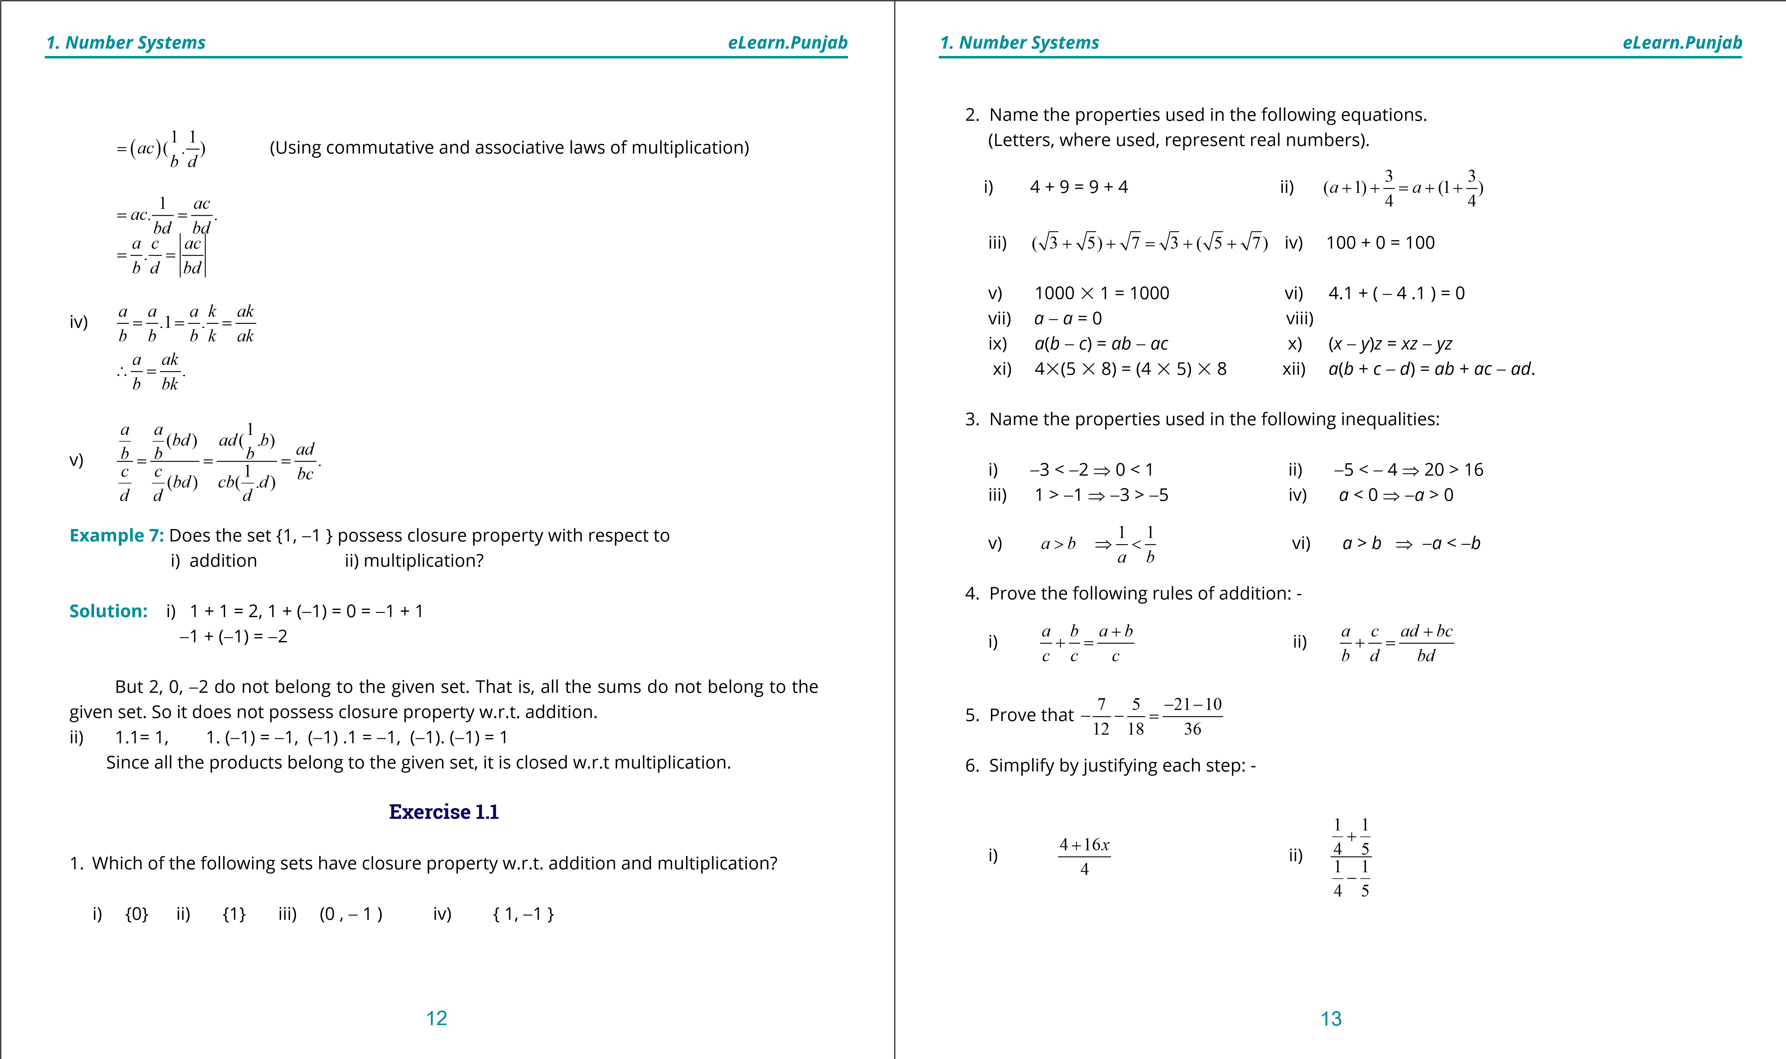

1. **Quadratic Equations eLearn.Punjab 1. Quadratic Equations eLearn.Punjab *1. Number Systems eLearn.Punjab 1. Number Systems eLearn.Punjab***

*a c* 1 1

+ -

iii) *ba dc* iv) *a* 1 1*b*

- 1- . *b d a b*

**1.4 Complex Numbers**

The history of mathematics shows that man has been developing and enlarging his concept of **number** according to the saying that “Necessity is the mother of invention”. In the remote past they stared with the set of counting numbers and invented, by stages, the negative numbers, rational numbers, irrational numbers. Since square of a positive as well as negative number is a positive number, the square

root of a negative number does not exist in the realm of real numbers. Therefore, square roots of negative numbers were given no attention for centuries together. However, recently, properties of numbers involving square roots of negative numbers have also been discussed in detail and such numbers have been found useful and have been applied in many branches o f pure and applied mathematics. The numbers of the form *x* + *iy*, where *x*, *y* U_ , and i = ,are called **complex numbers,** here *x* is called **real part** and y is called **imaginary part** of the complex number. For example, 3 + 4i, 2 - *i* etc. are complex numbers.

11

2

**Note:** Every real number is a complex number with 0 as its imaginary part.

Let us start with considering the equation.

*x*2 + 1 = 0 (1)

⇒ *x*2 = -1

⇒ *x* = ± -1

-1does not belong to the set of real numbers. We, therefore, for convenience call it **imaginary number** and denote it by *i* (read as iota). The product of a real number and *i* is also an **imaginary number**

Thus 2*i*, -3*i*, 5*i ,* - *i* are all imaginary numbers, *i* which may be written 1.*i* is also an imaginary number.

**Powers of** *i* **:**

*i*2 = -1 (by deination)

*i*3 = *i*2.*i =* -1*.i =* -*i*

*i*4 = *i*2 % *i*2 *=* (-1)(-1) *=* 1

Thus any power of *i* must be equal to 1, *i*,-1 or -*i.* For instance, *i*13 = (*i*2)6.2 *=* (-1)6*.i = i i*6 = (*i*2)3 *=* (-1)3 *=* -1 etc.

**1.4.1 Operations on Complex Numbers**

With a view to develop algebra of **complex numbers**, we state a few deinitions.

The symbols *a,b,c,d,k*, where used, represent real numbers.

1. *a* + *bi* = *c* + *di*  ⇒ *a* = *c* *b* = *d*.
2. Addition: (*a* + *bi*) + (*c* + *di*) = (*a* + *c*) + (*b* + *d*)*i*
3. *k*(*a* + *bi*) = *ka* + *kbi*
4. (*a* + *bi*) - (*c* + *di*) = (*a* + *bi*) + [-(*c* + *di*)]

= *a* + *bi* + (-*c* - *di*)

= (*a* - *c*) + (*b* - *d*)*i*

1. (*a* + *bi*).(*c* + *di*) = *ac* + *adi* + *bci* + *bdi* = (*ac* - *bd*) + (*ad* + *bc*)*i*.
2. **Conjugate Complex Numbers:** Complex numbers of the form (a + b*i*) and (a - b*i*) which have the same real parts and whose imaginary parts difer in sign only, are called conjugates of each other. Thus 5 + 4*i* and 5 - 4*i*, -2 + 3*i* and - 2 - 3*i*,- 5 *i* and 5 *i* are three pairs of conjugate numbers.

**Note:** A real number is self-conjugate.

**1.4.2 Complex Numbers as Ordered Pairs of Real Numbers**

We can deine complex numbers also by using ordered pairs. Let *C* be the set of ordered pairs belonging to _ % _ which are subject to the following properties: -

14 15

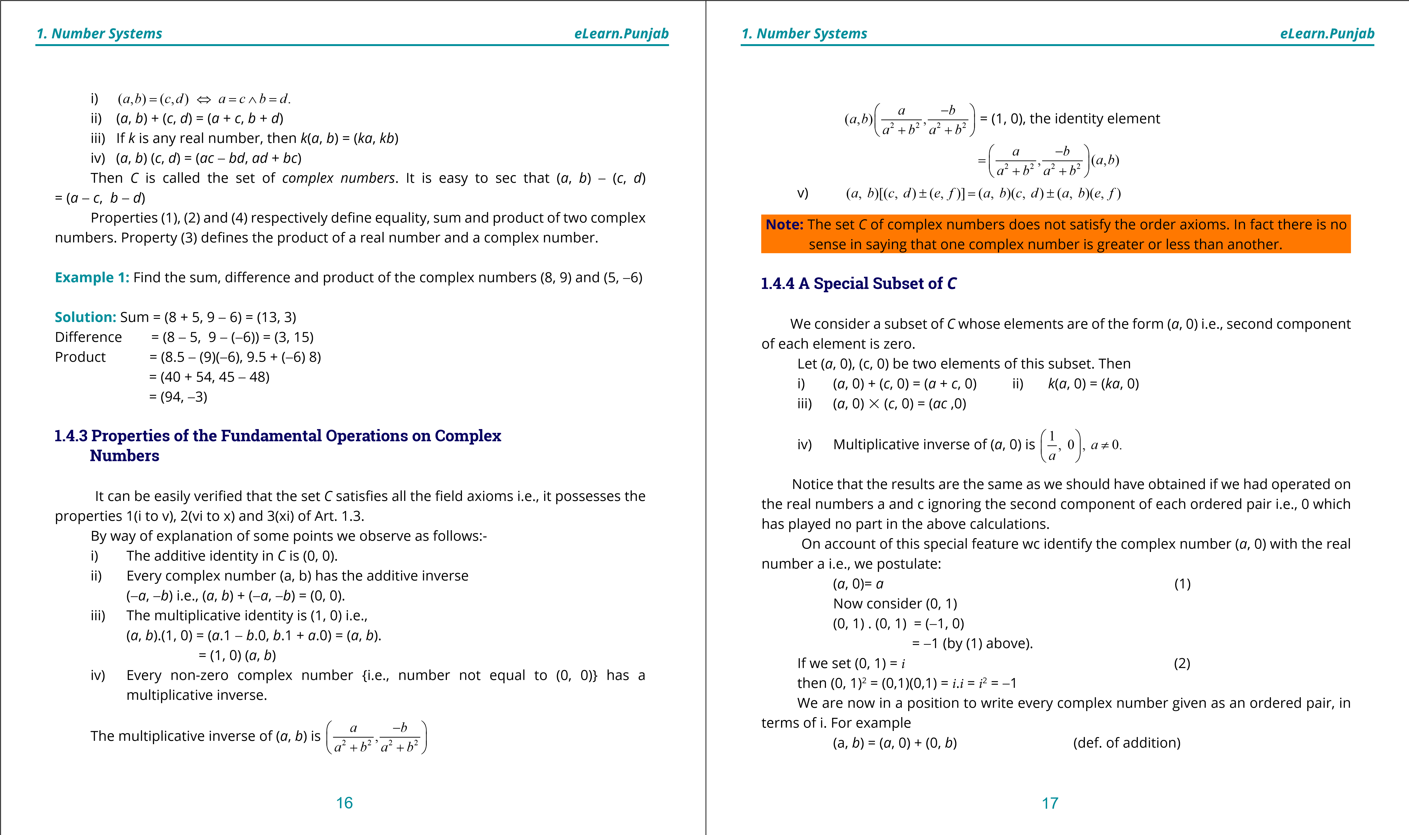

**1. Quadratic Equations eLearn.Punjab 1. Quadratic Equations eLearn.Punjab *1. Number Systems eLearn.Punjab 1. Number Systems eLearn.Punjab***

= *a*(1, 0)+ *b*(0, 1) (by ( 1) and (2) above)

= *a*.1 + *bi*

= *a* + *ib*

Thus (*a*, *b*) = *a* + *ib* where *i*2 = -1

This result enables us to convert any Complex number given in one notation into the other.

**Exercise 1.2**

1. Verify the addition properties of complex numbers.
2. Verify the multiplication properties of the complex numbers.
3. Verify the distributive law of complex numbers.

(*a*, *b*)[(*c*, *d*) + (*e*, *f*)] = (*a*, *b*)(*c*, *d*) + (*a*, *b*)(*e*, *f*) (**Hint:** Simplify each side separately) **4.** Simplify’ the following:

i) *i*9 ii) *i*14  iii) (-*i*)19 iv) (- )

1. Write in terms of *i*

i) -1*b* ii) -5 iii) -16 iv) 1

25 -4

Simplify the following:

1. (7, 9 ) + (3, -5) **7.** (8, -5 ) - (-7, 4) **8.** (2, 6)(3, 7)

**9.** (5, -4) (-3, -2) **10.** (0, 3) (0, 5) **11.** (2, 6)'(3, 7).

1. (5, -4) '(-3, -8) Hint for 11: (2(3,,7)6) = 32++76*ii* × 33-- 77*ii* etc. 
2. Prove that the sum as well as the product of any two conjugate complex numbers is a real number.
3. Find the multiplicative inverse of each of the following numbers:

i) (-4, 7) ii) ( 2, - 5) iii) (1, 0) **15.** Factorize the following:

i) *a*2 + 4*b*2 ii) 9*a*2 + 16*b*2 iii) 3*x*2 +3*y*2

**16.** Separate into real and imaginary parts (write as a simple complex number): -

2 - 7*i* ( 2- + 3 )*i* 2 *i*

i) ii) iii)

4 + 5*i* (1+ *i*) 1+ *i*

**1.5 The Real Line**



In Fig.(1), let *X*′ *X*be a line. We represent the number 0 by a point *O* (called the origin) of the line. Let |*OA*| represents a unit length. According to this unit, positive numbers are represented on this line by points to the right of *O* and negative numbers by points to the left of *O*. It is easy to visualize that all +ve and -ve rational numbers are represented on this line. What about the irrational numbers?

21

2

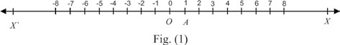

The fact is that all the irrational numbers are also represented by points of the line. Therefore, we postulate: -

**Postulate:** A (1 - 1) correspondence can be established between the points of a line l and the real numbers in such a way that:-

i) The number 0 corresponds to a point *O* of the line. ii) The number 1 corresponds to a point *A* of the line.

iii) If *x*1, *x*2 are the numbers corresponding to two points *P*1, *P*2, then the distance between *P*1 and *P*2 will be |*x*1 - *x*2|.

It is evident that the above correspondence will be such that corresponding to any real number there will be one and only one point on the line and vice versa.

When a (1 - 1) correspondence between the points of a line *x x*′and the real numbers has been established in the manner described above, the line is called the **real line** and the real number, say *x*, corresponding to any point *P* of the line is called the **coordinate** of the point.

**1.5.1 The Real Plane or The Coordinate Plane**

We know that the *cartesian product* of two non-empty sets *A* and *B,* denoted by *A* % *B*, is the set: *A* % *B* = {(x, y) I *x*U*A /* yU*B*}

18 19

**1. Quadratic Equations eLearn.Punjab 1. Quadratic Equations eLearn.Punjab *1. Number Systems eLearn.Punjab 1. Number Systems eLearn.Punjab***

The members of a *cartesian* product are **ordered pairs.**

The cartesian product _%_ where _ is the set of real numbers is called the **cartesian plane**. By taking two perpendicular lines *x ox*′ and *y oy*′ as coordinate axes on a geometrical plane and choosing a convenient unit of distance, elements of _%_ can be represented on the plane in such a way that there is *a* (1-1) correspondence between the elements of _%_ and points of the plane.

The geometrical plane on which coordinate system has been speciied is called the **real plane** or the **coordinate plane**.

Ordinarily we do not distinguish between the Cartesian plane _%_ and the coordinate plane whose points correspond to or represent the elements of _%_.

If a point *A* of the coordinate plane corresponds to the ordered pair (*a*, *b*) then *a*, *b* are called the **coordinates** of *A*. *a* is called the *x* - coordinate or **abscissa** and *b* is called the y - coordinate or **ordinate**.

In the igure shown above, the coordinates of the points*B, C, D* and *E* are (3, 2), (-4, 3), (-3, -4) and (5, -4) respectively.

Corresponding to every ordered pair (*a, b*) U_%_ there is one and only one point in the plane and corresponding to every point in the plane there is one and only one ordered pair (*a, b*) in _%_.

There is thus a (1 - 1) correspondence between _%_ and the plane.

**1.6 Geometrical Representation of Complex Numbers The Complex Plane**

We have seen that there is a (1-1) correspondence between the elements (ordered pairs) of the Cartesian plane _%_ and the complex numbers. Therefore, there is a (1- 1) correspondence between the points of the coordinate plane and the complex numbers. We can, therefore, represent complex numbers by points of the coordinate plane. In this representation every complex number will be represented by one and only one point of the coordinate plane and every point of the plane will represent one and only one complex number. The components of the complex number will be the coordinates of the point representing it. In this representation the ***x*-axis** is called the real axis and the ***y*-axis** is called the **imaginary axis**. The coordinate plane itself is called the **complex plane** or **z** - **plane**.

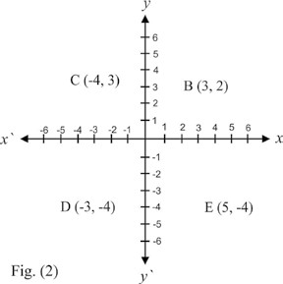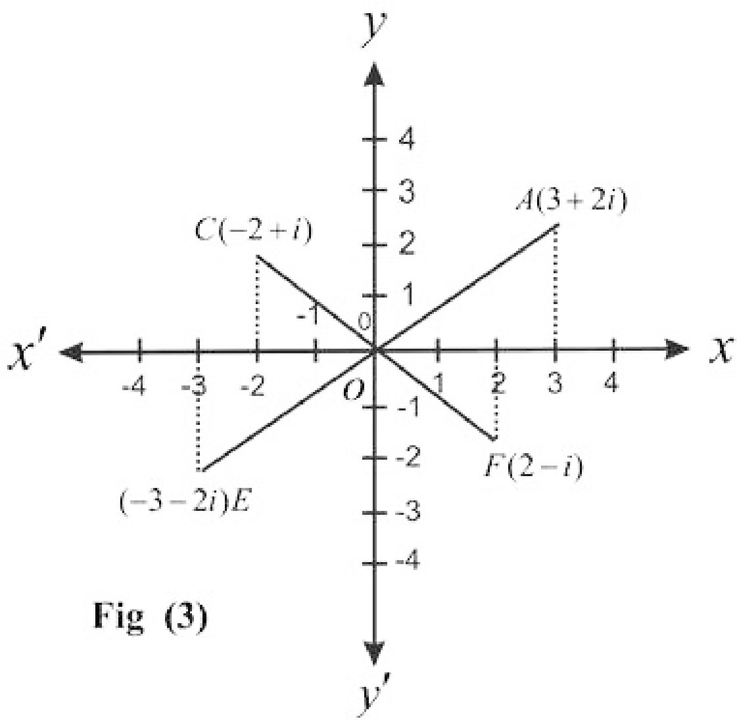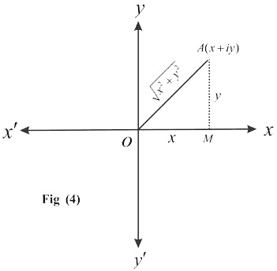

By way of illustration a number of complex numbers have been shown in igure 3.

The igure representing one or more complex numbers on the *complex plane* is called an **Argand diagram**. Points on the **x-axis** represent **real numbers** whereas the points on the **y-axis** represent **imaginary numbers.**

In ig (4), *x*, *y* are the coordinates of a point. It represents the complex number *x* + *iy*. The *real number x*2 + *y*2 is called **the modulus**

**of the complex number** ***a + ib*.**

In the igure *MA* ⊥ *o x*

∴*OM* = *x*, *MA* = *y*

In the right-angled triangle *OMA*, we have, by Pythagoras theorem,

*OA* 2 = *OM* 2 + *MA* 2

∴ *OA* = *x*2 + *y*2

Thus *OA* represents the modulus of *x* + *iy*. In other words: **The modulus of a complex** **number is the distance from the origin of the point representing the number.**

20 21

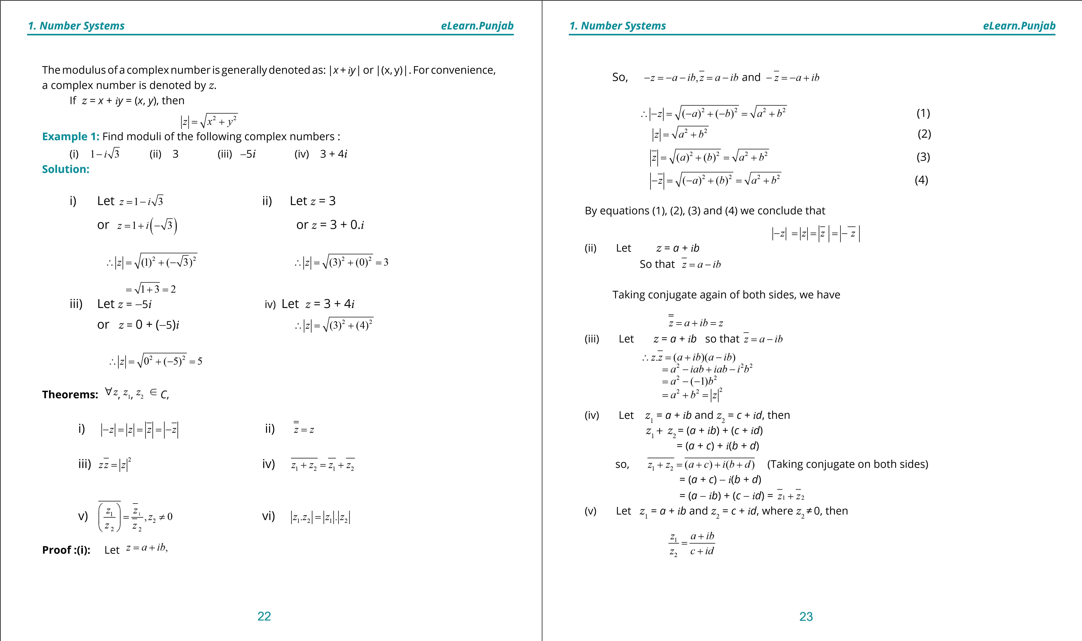

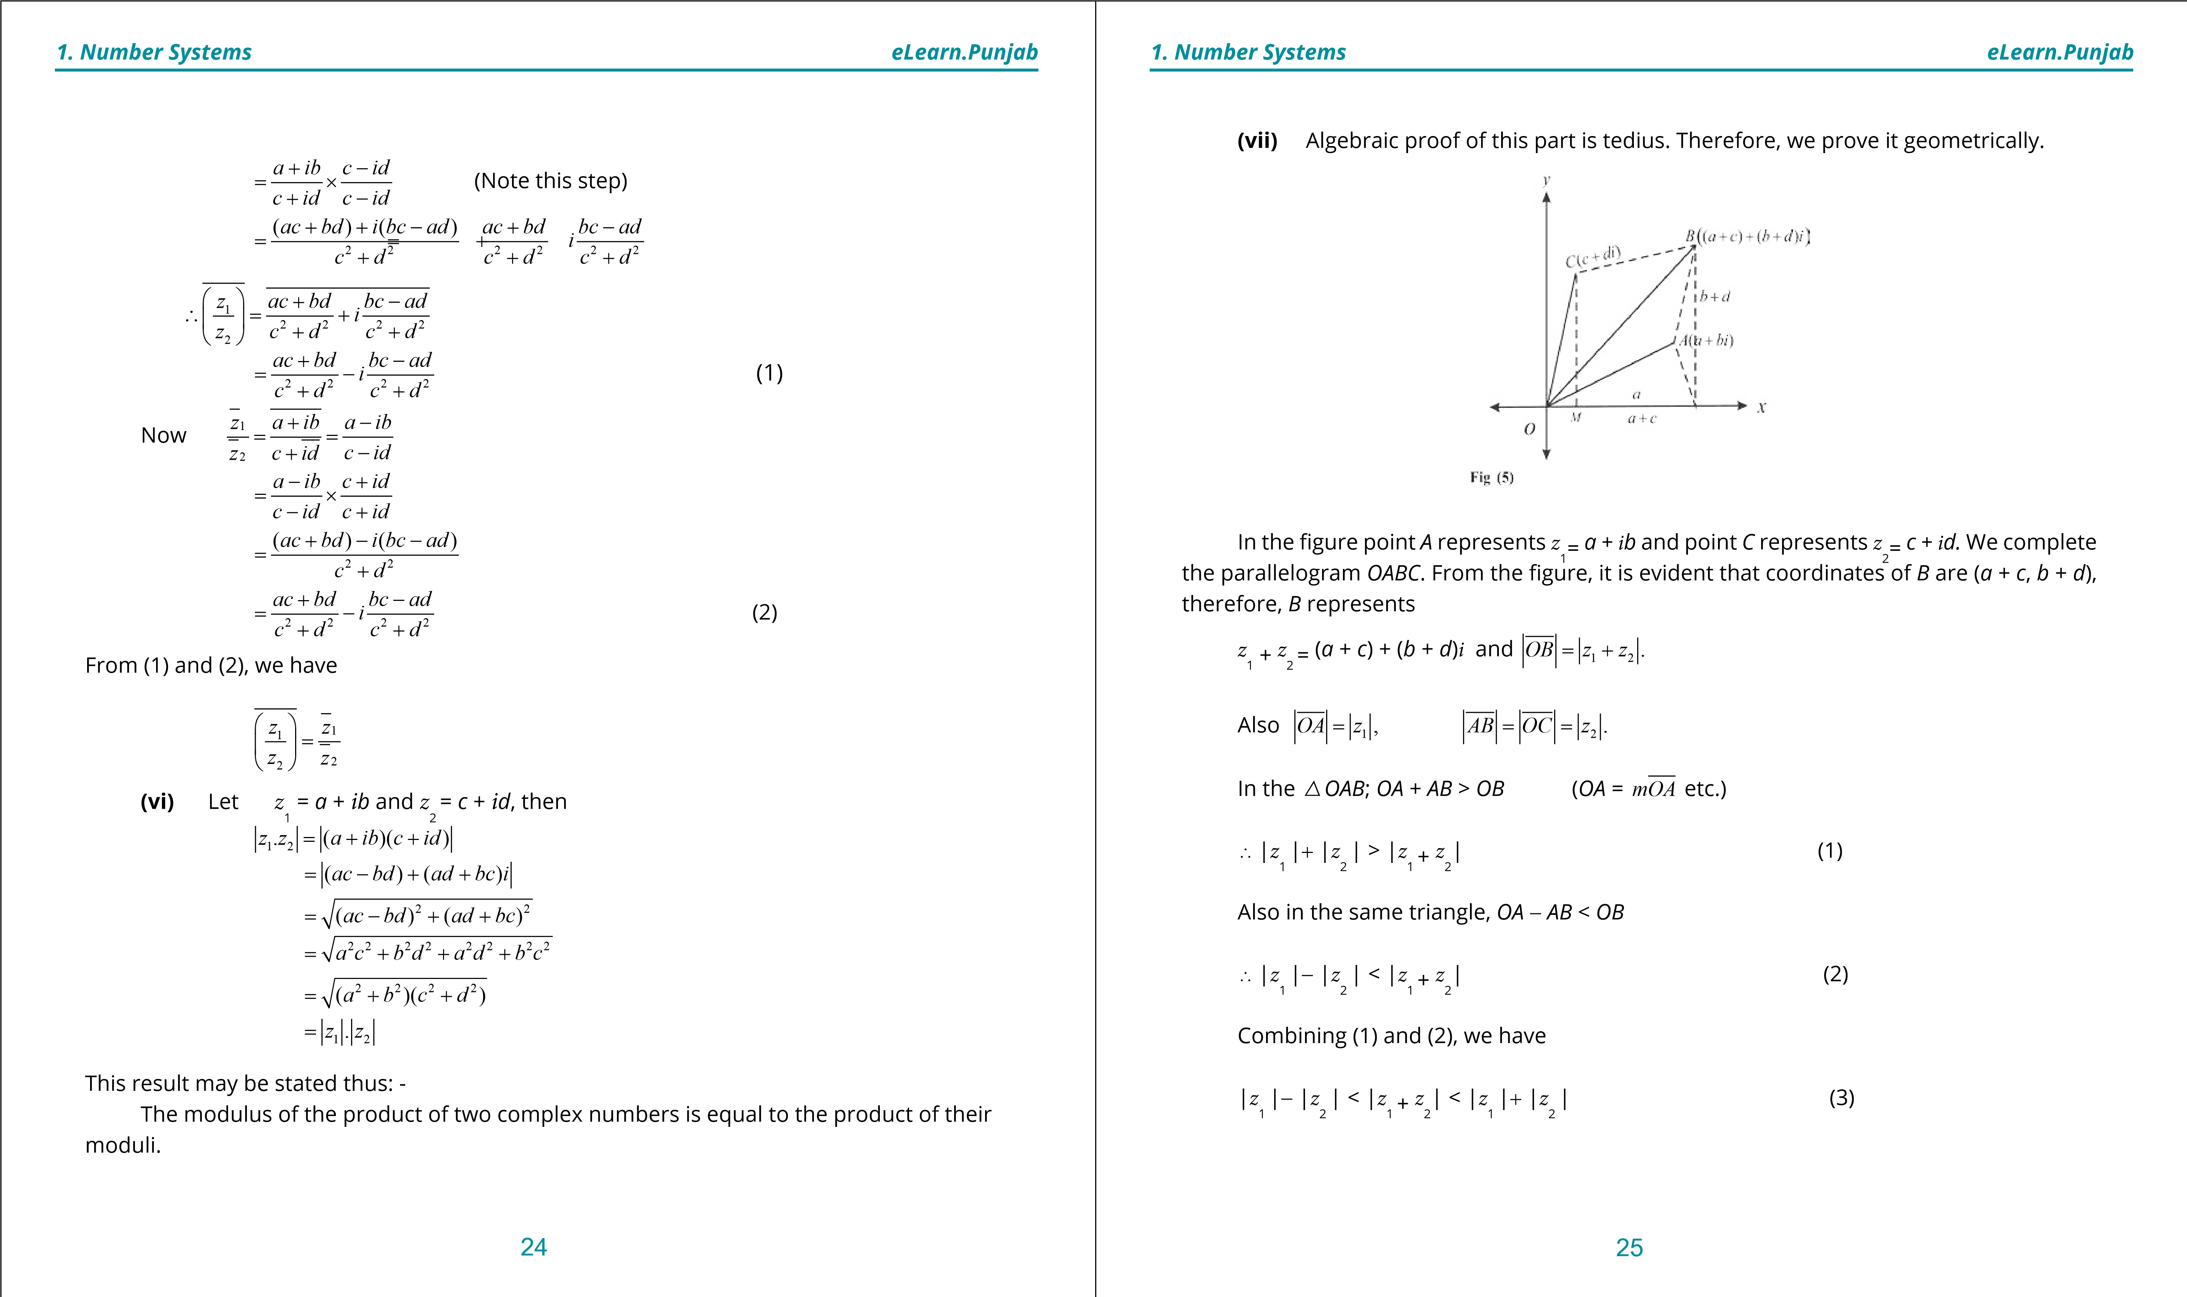

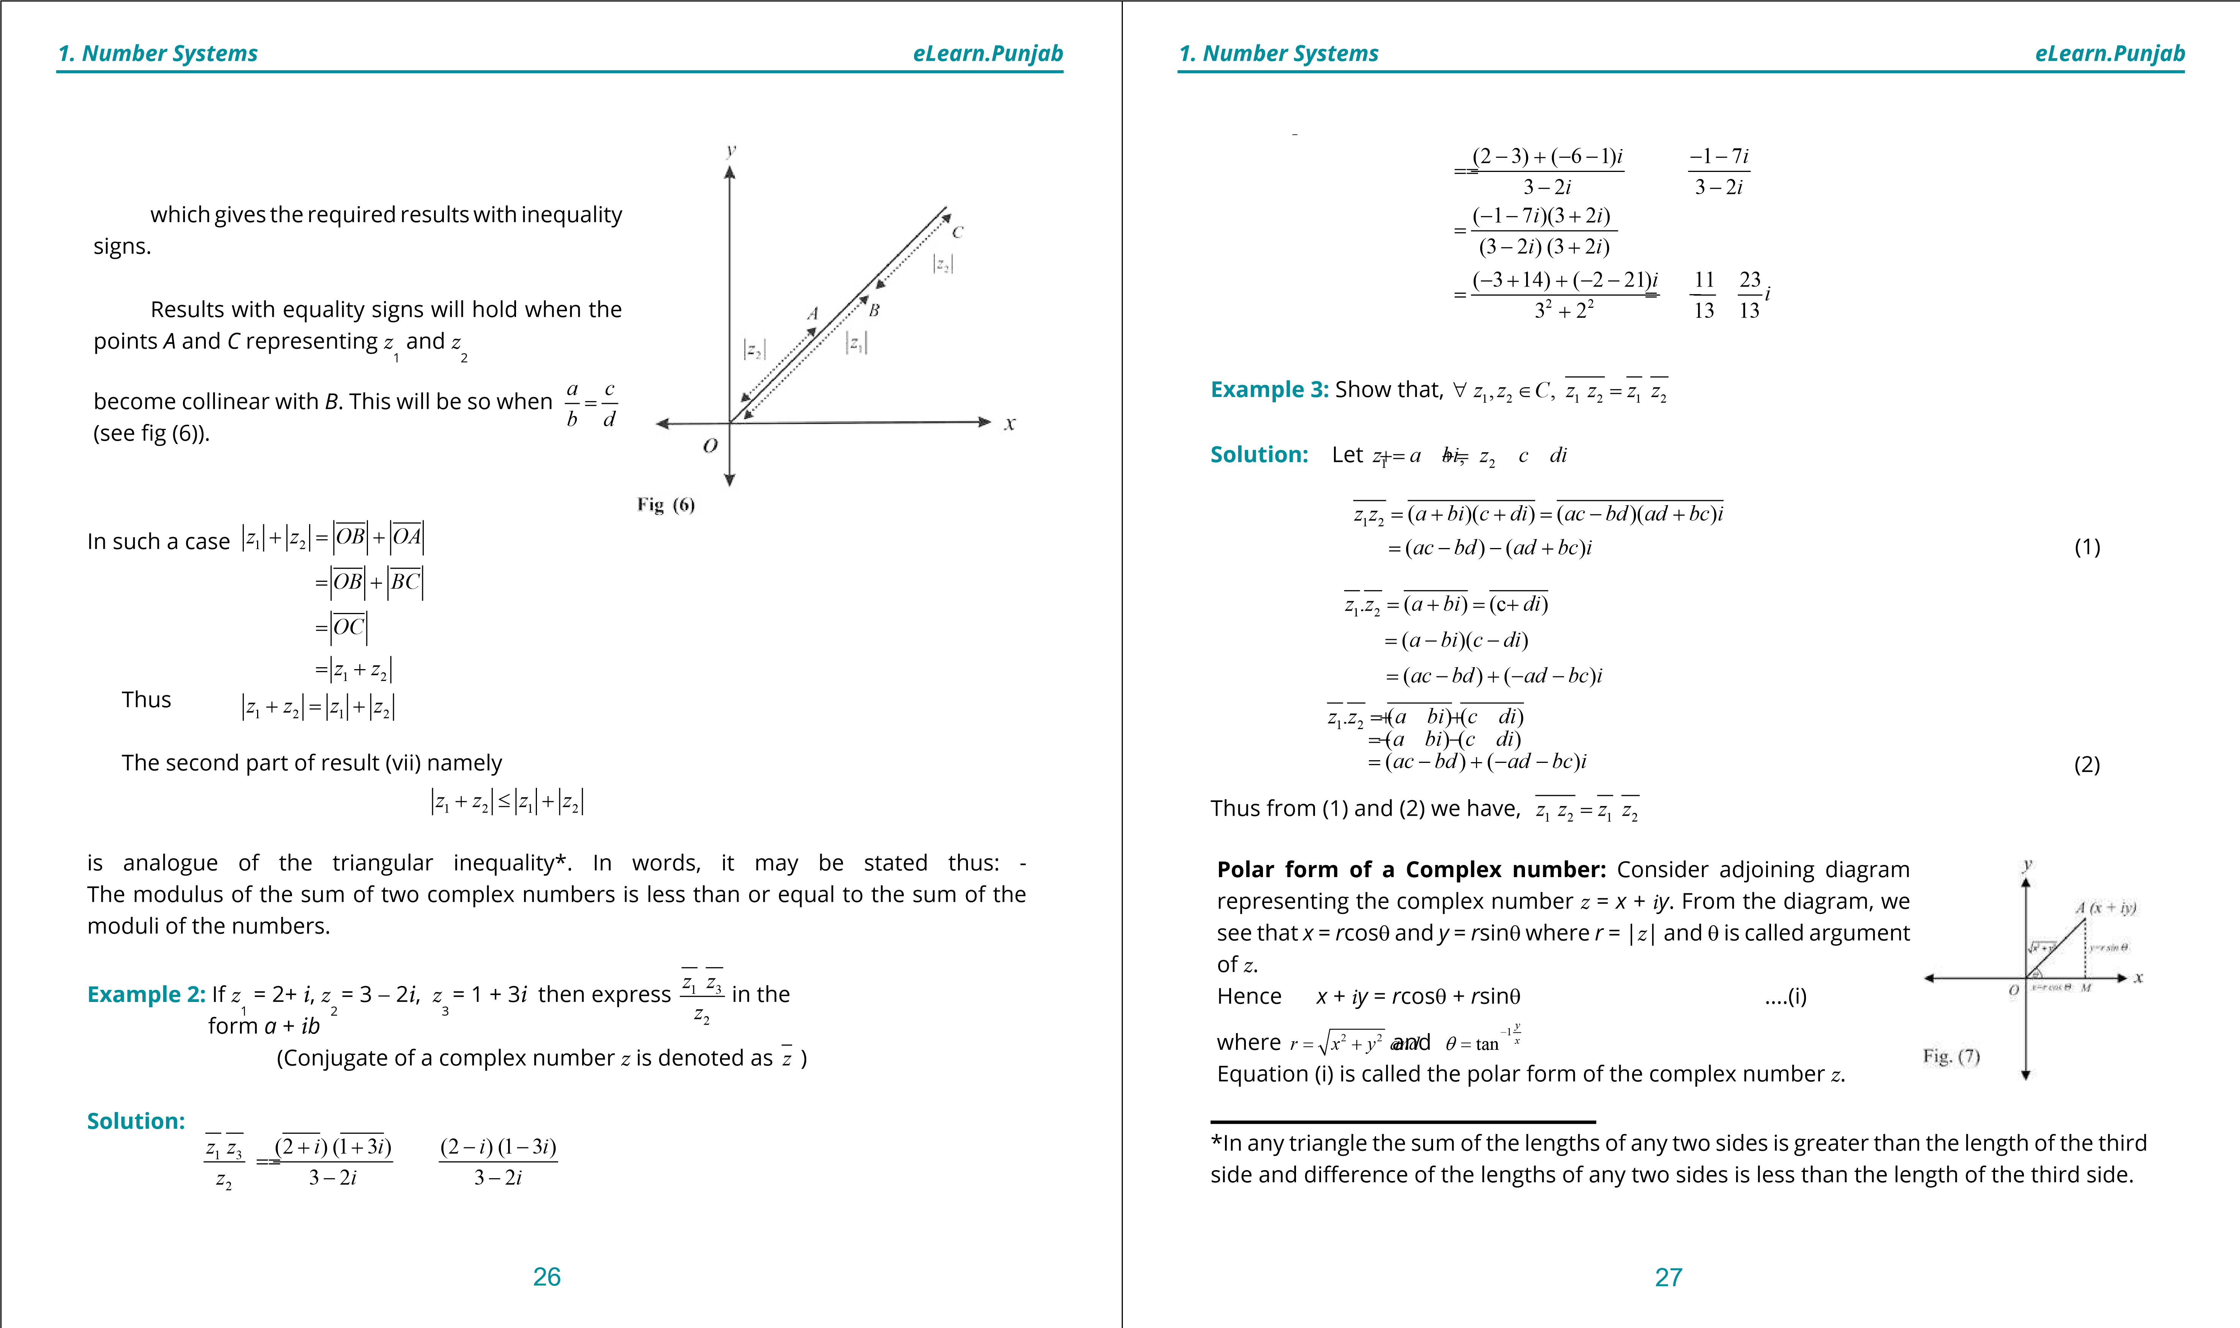

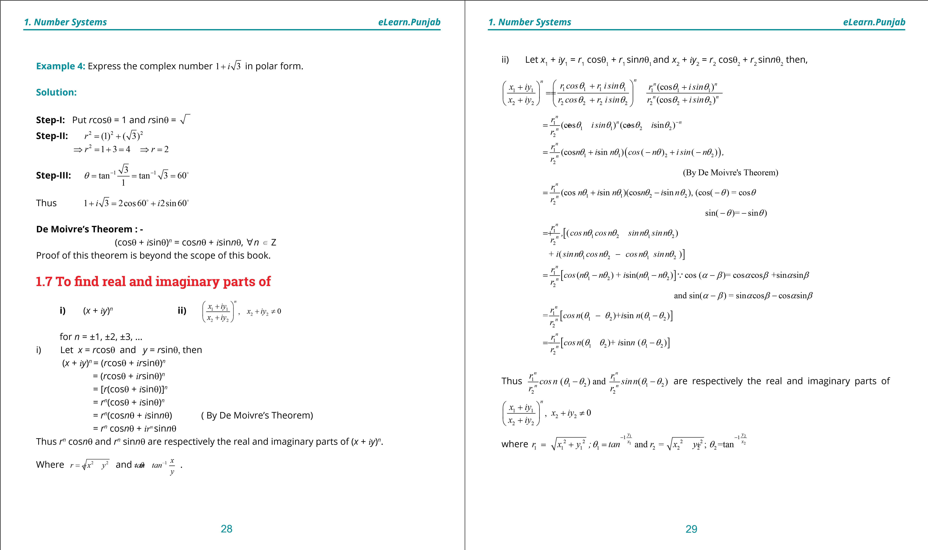

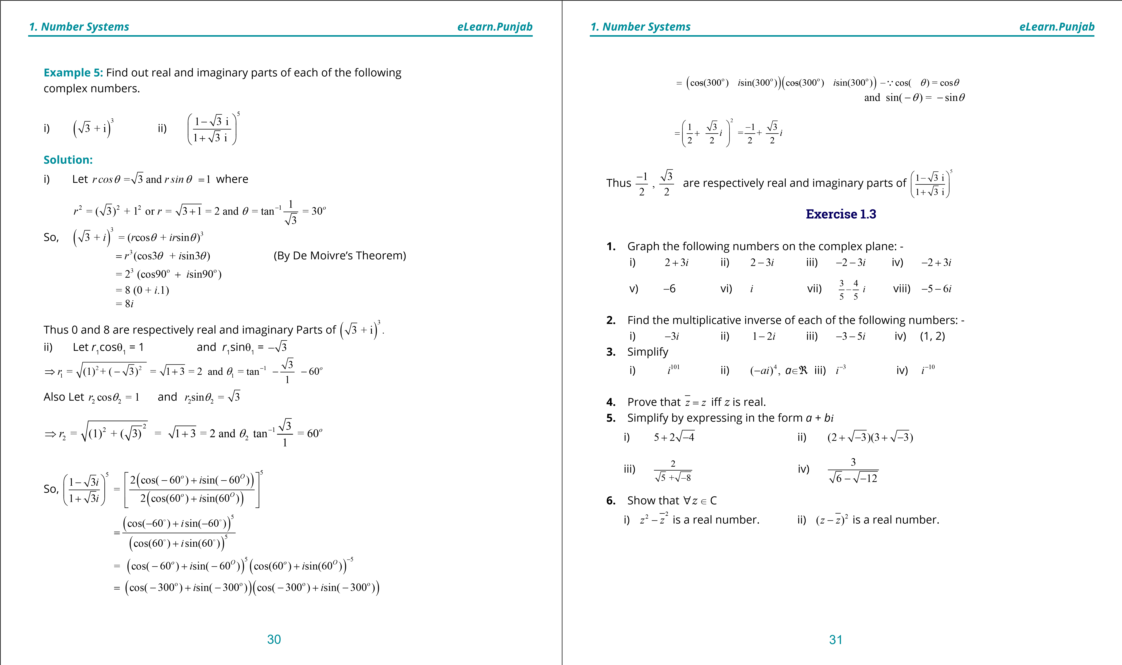

**. Quadratic Equations**

**1**

**eLearn.Punjab**

***. Number Systems***

***1***

***eLearn.Punjab***

32

**7.**

Simplify the following

i)

3

3

1

2

2

*i*





-

+









ii)

3

3

1

2

2

*i*





-

-









iiii)

2

1

3

1

3

2

2

2

2

*i*

*i*

-









-

-

-

-

















iv)

2

(

)

*bi*

*a*

+

v)

2

(

)

*a*

*bi*

-

+

vi)

3

(

)

*a*

*bi*

+

vii)

3

(

)

*a*

*bi*

-

viii)

3

(3

4)

-

-

-

***version: 1.1***

CHAPTER

3 Matrices and

Determinants

*Animation 3.1: Addition of matrix*

*Source & Credit: elearn.punjab*

**1. Quadratic Equations eLearn.Punjab 1. Quadratic Equations eLearn.Punjab 3. Matrices and Determinants *eLearn.Punjab* 3. Matrices and Determinants *eLearn.Punjab***

**3.1 Introduction**

While solving linear systems of equations, a new notation was introduced to reduce the amount of writing. For this new notation the word matrix was irst used by the English mathematician James Sylvester (1814 - 1897). Arthur Cayley (1821 - 1895) developed the theory of matrices and used them in the linear transformations. Now-a-days, matrices are used in high speed computers and also in other various disciplines.

The concept of determinants was used by Chinese and Japanese but the Japanese mathematician Seki Kowa (1642 - 1708) and the German Mathematician Gottfried Wilhelm Leibniz (1646 - 1716) are credited for the invention of determinants. G. Cramer (1704 - 1752) applied the determinants successfully for solving the systems of linear equations. A rectangular array o f numbers enclosed by a pair o f brackets such as:

2 3 0 

-25 4 7-1 3 (i) or 134 -121 -641 (ii) 

is called a **matrix**. The horizontal lines of numbers are called **rows** and the vertical lines of numbers are called **columns**. The numbers used in rows or columns are said to be the **entries** or **elements** of the matrix.

The matrix in (i) has two rows and three columns while the matrix in (ii) has 4 rows and three columns. Note that the number of elements of the matrix in (ii) is 4 % 3 = 12. Now we give a general deinition of a matrix.

Generally, a bracketed rectangular array of *m*%*n* elements *a*ij (*i* = 1, 2, 3, ...., *m*; *j* = 1, 2, 3, ...., *n*), arranged in *m* rows and *n* columns such as:

*a*11 *a*12 *a*13 ☹ *a*1*n* 

(iii)*a*21 *a*22 *a*23 ☹ *a*2*n* 



     

*am*1 *am*2 *am*3 ☹ *amn* 

is called an *m* by *n* matrix (written as *m* % *n* matrix).

*m* % *n* is called the order of the matrix in (iii). We usually use capital letters such as *A, B,*

*C, X, Y*, etc., to represent the matrices and small letters such as *a, b, c,... I, m, n,...,a11 , a12 , a13* ,...., etc., to indicate the entries of the matrices.

Let the matrix in (iii) be denoted by *A*. The *i*th row and the *j*th column of *A* are indicated in the following tabular representation of *A*.

*j*th column F

*a*11 *a*12 *a*13 ☹ *a*1 *j* ☹ *a*1*n*  *a*21 *a*22 *a*23 ☹ *a*2 *j* ☹ *a*2*n* 

*a*31 *a*32 *a*33 ☹ *a*3 *j* ☹ *a*3*n* 

*A =*        (iv)  *i*th row D  *ai*1 *ai*2 *ai*3 ☹ *aij* ☹ *ain* 

      

*am*1 *am*2 *am*3 ☹ *amj* ☹ *amn* 

The elements of the *i*th row o f *A* are *a*i1 *a*i2  *a*i3 ...... *aij* ...... *ain* while the elements of the *j*th column of A are *a*1*j* *a*2*j* *a*3*j*.... *aij* ...... *amj* .

We note that *aij* is the element of the *i*th row and *j*th column of *A*. The double subscripts are useful to name the elements of the matrices. For example, the element 7 is at *a*23 position in the matrix -25 -41 73

A = [*aij*]*m*%*n* or A = [*aij*], for *i* = 1, 2, 3,...., *m*; *j* = 1, 2, 3,...., *n*, where *aij* is the element of the *i*th row and *j*th column of *A*.

**Note:** *aij* is also known as the (*i*, *j*)th element or entry of *A*.

The elements (entries) of matrices need not always be numbers but in the study of matrices, we shall take the elements o f the matrices from _ or from *C*.

2 3

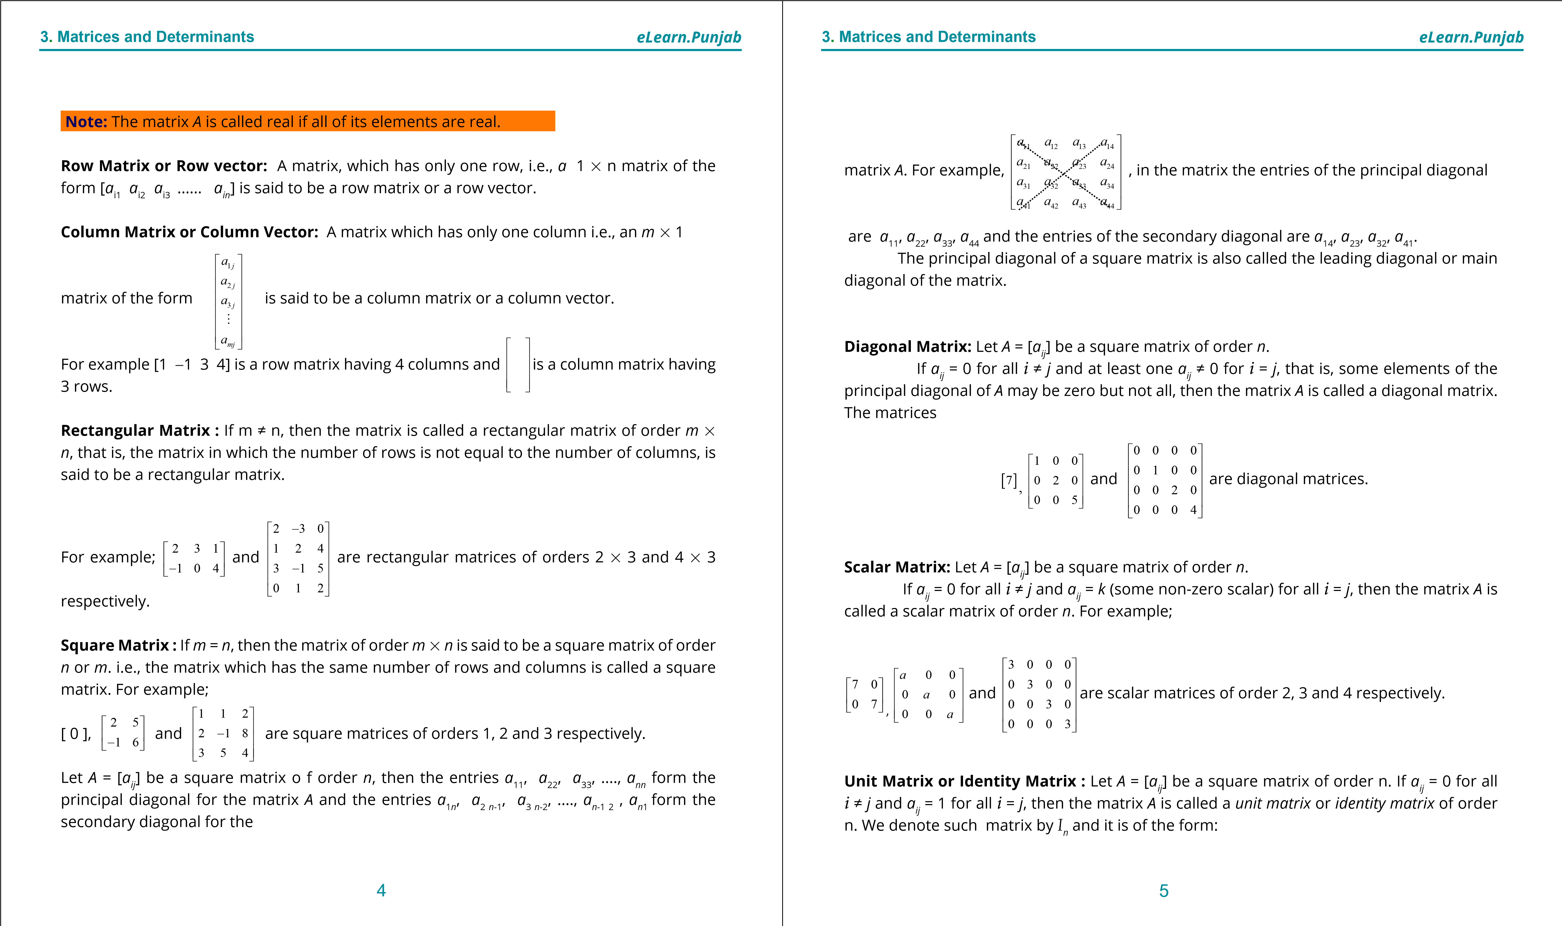

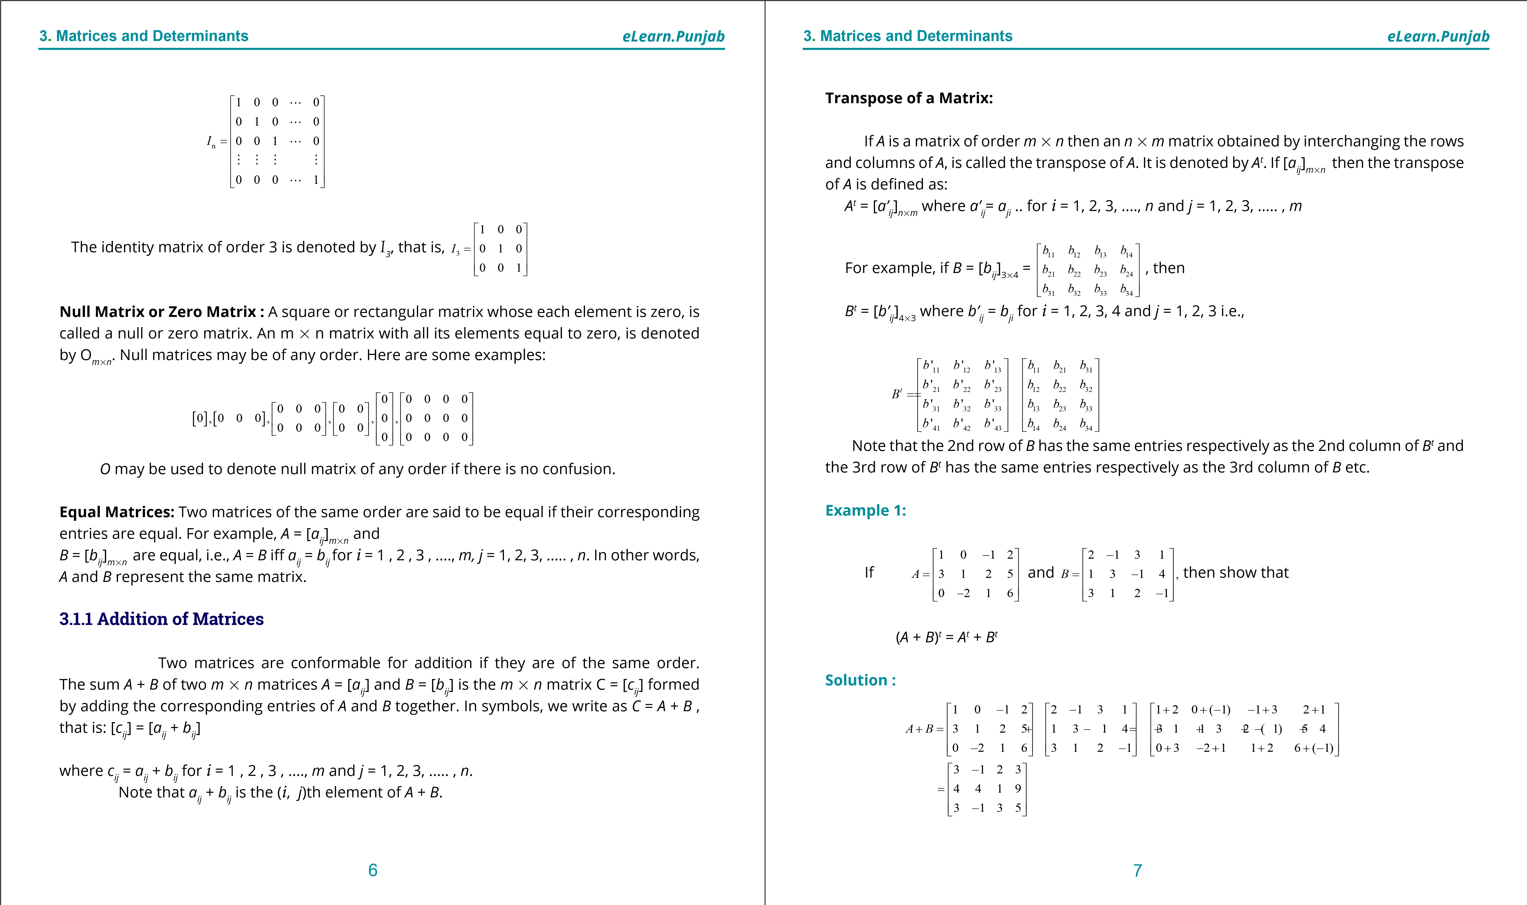

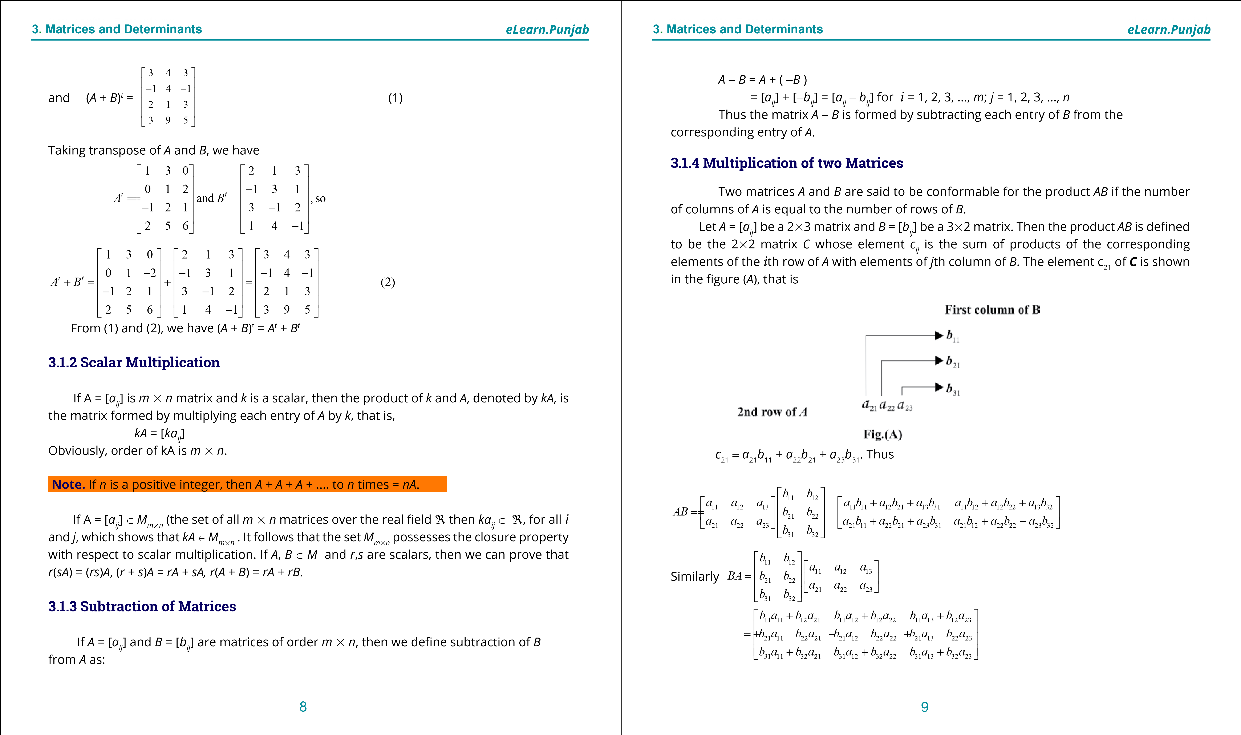

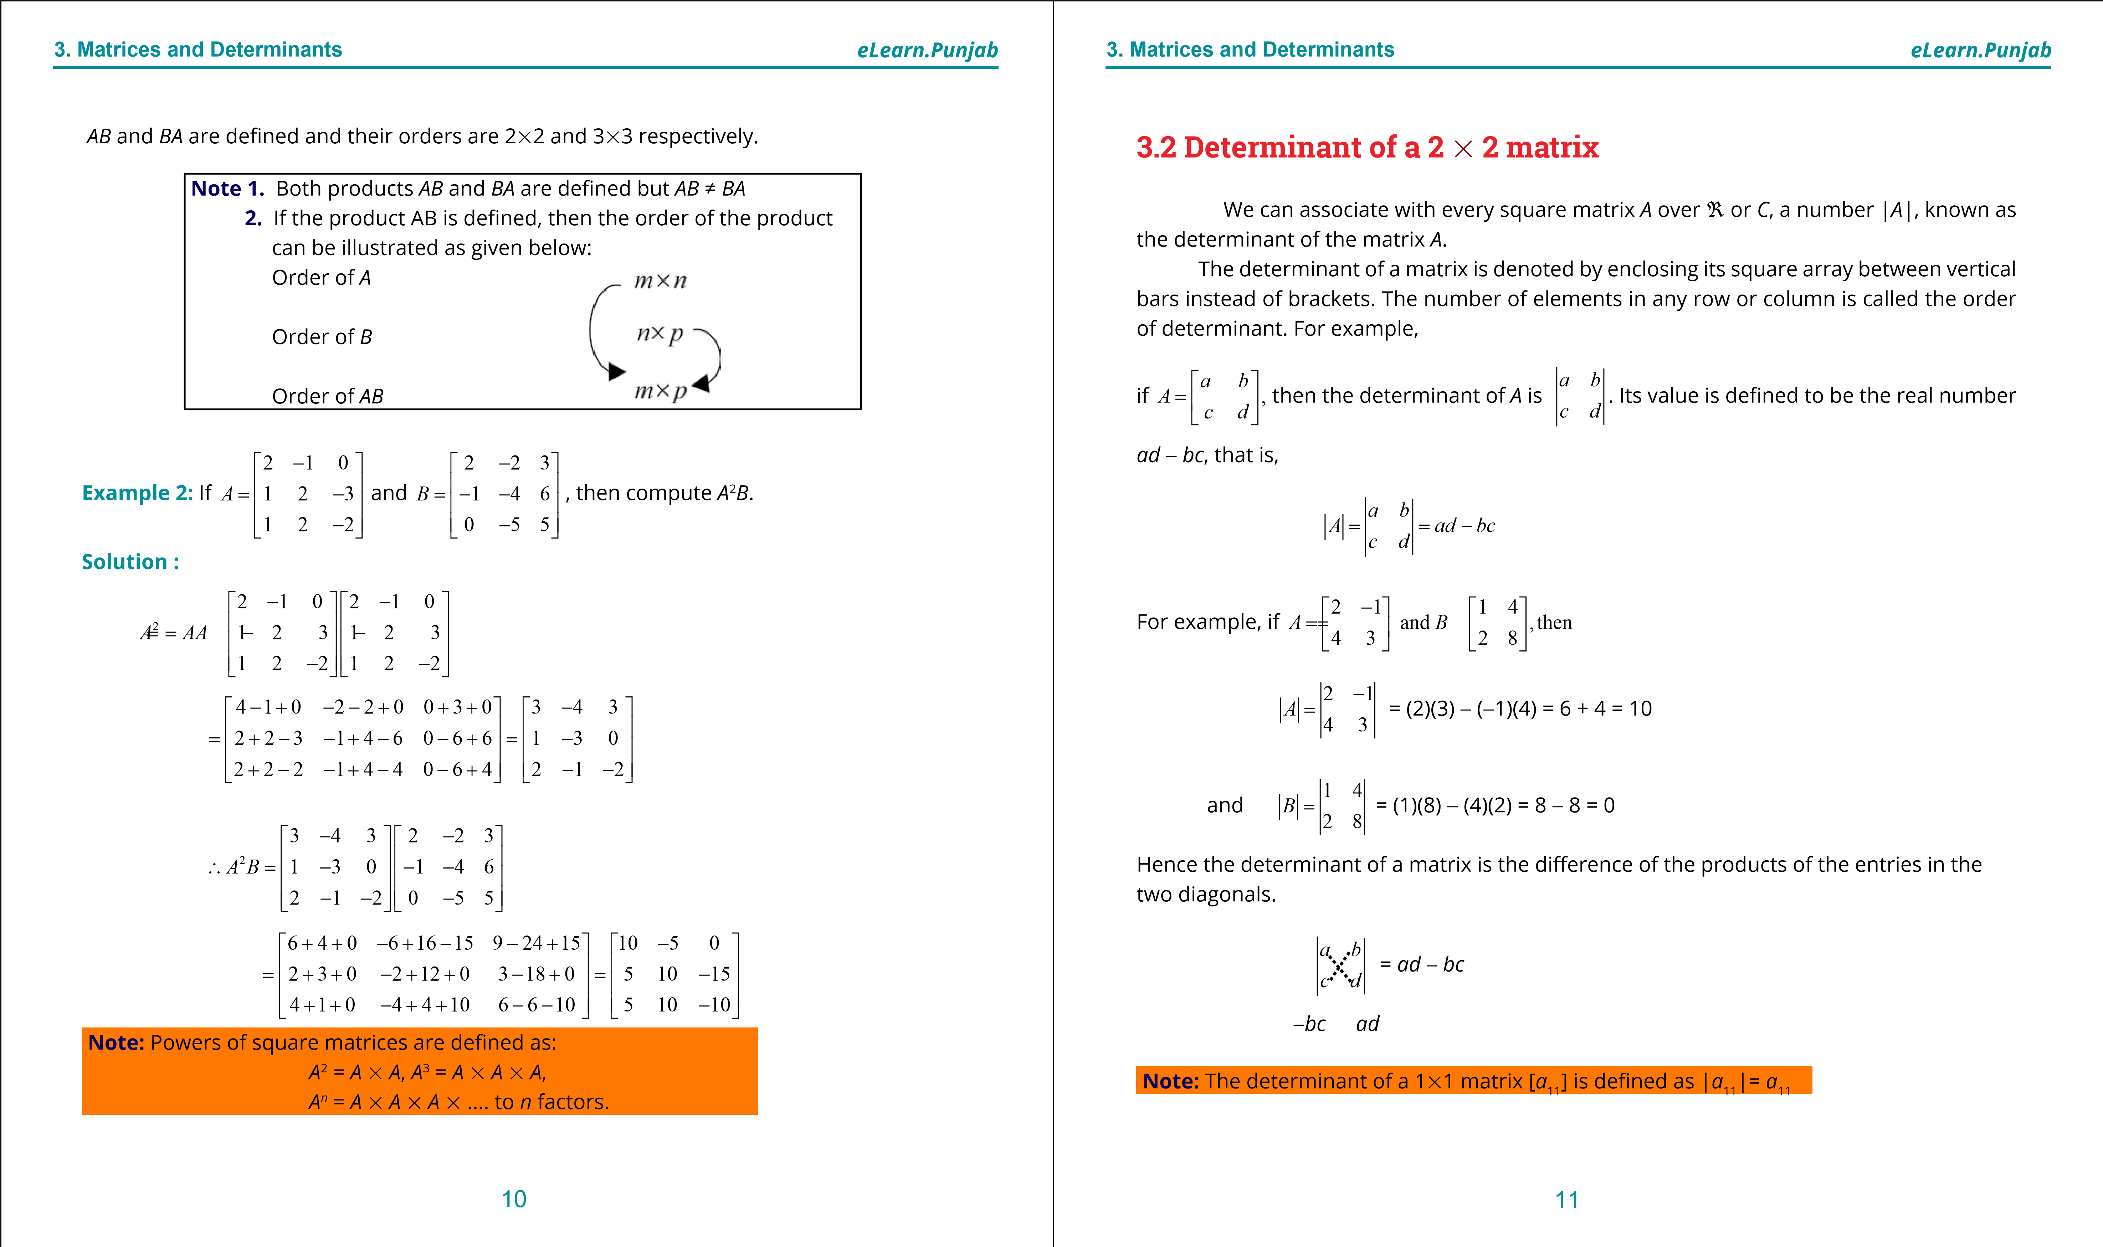

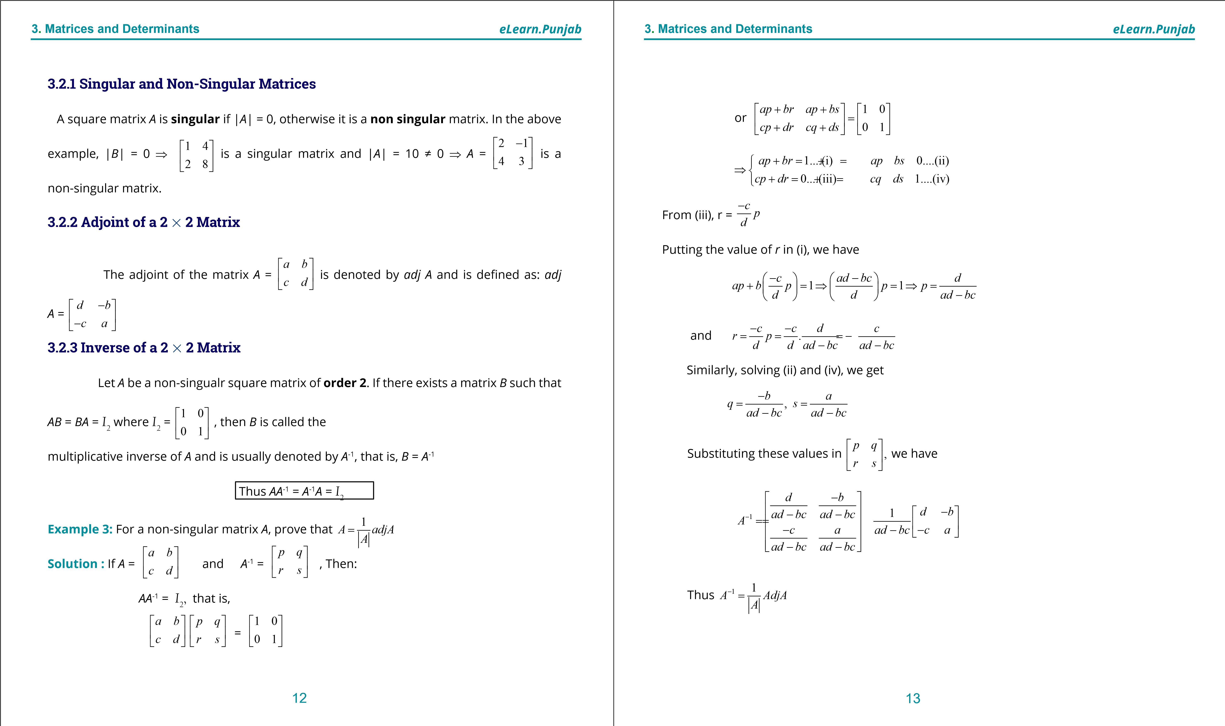

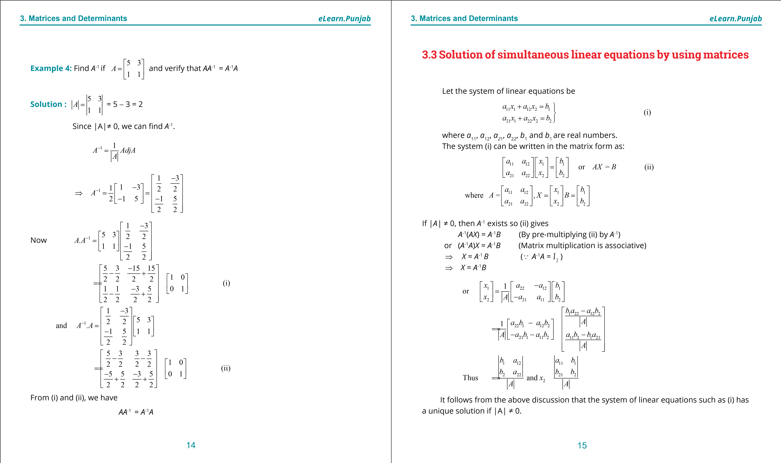

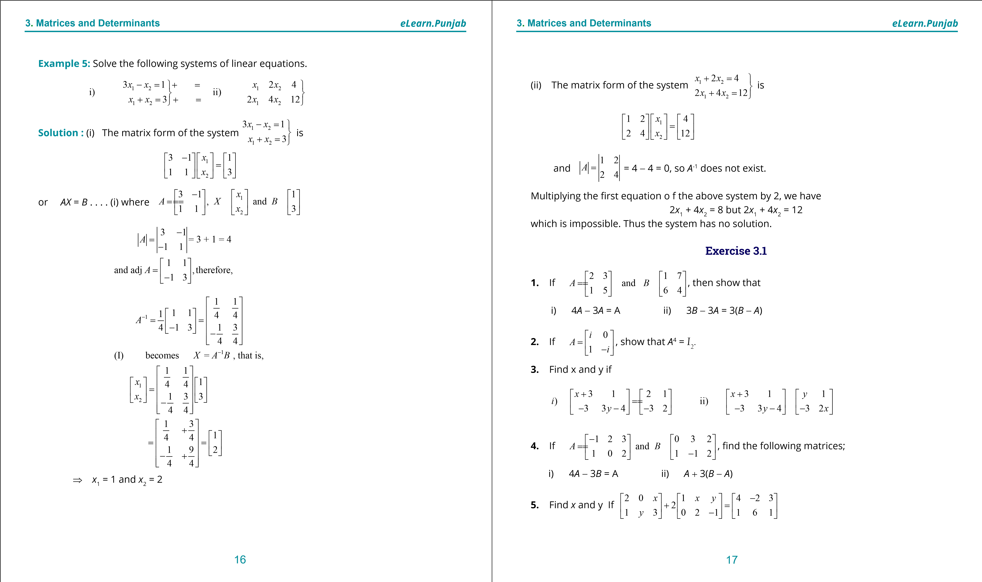

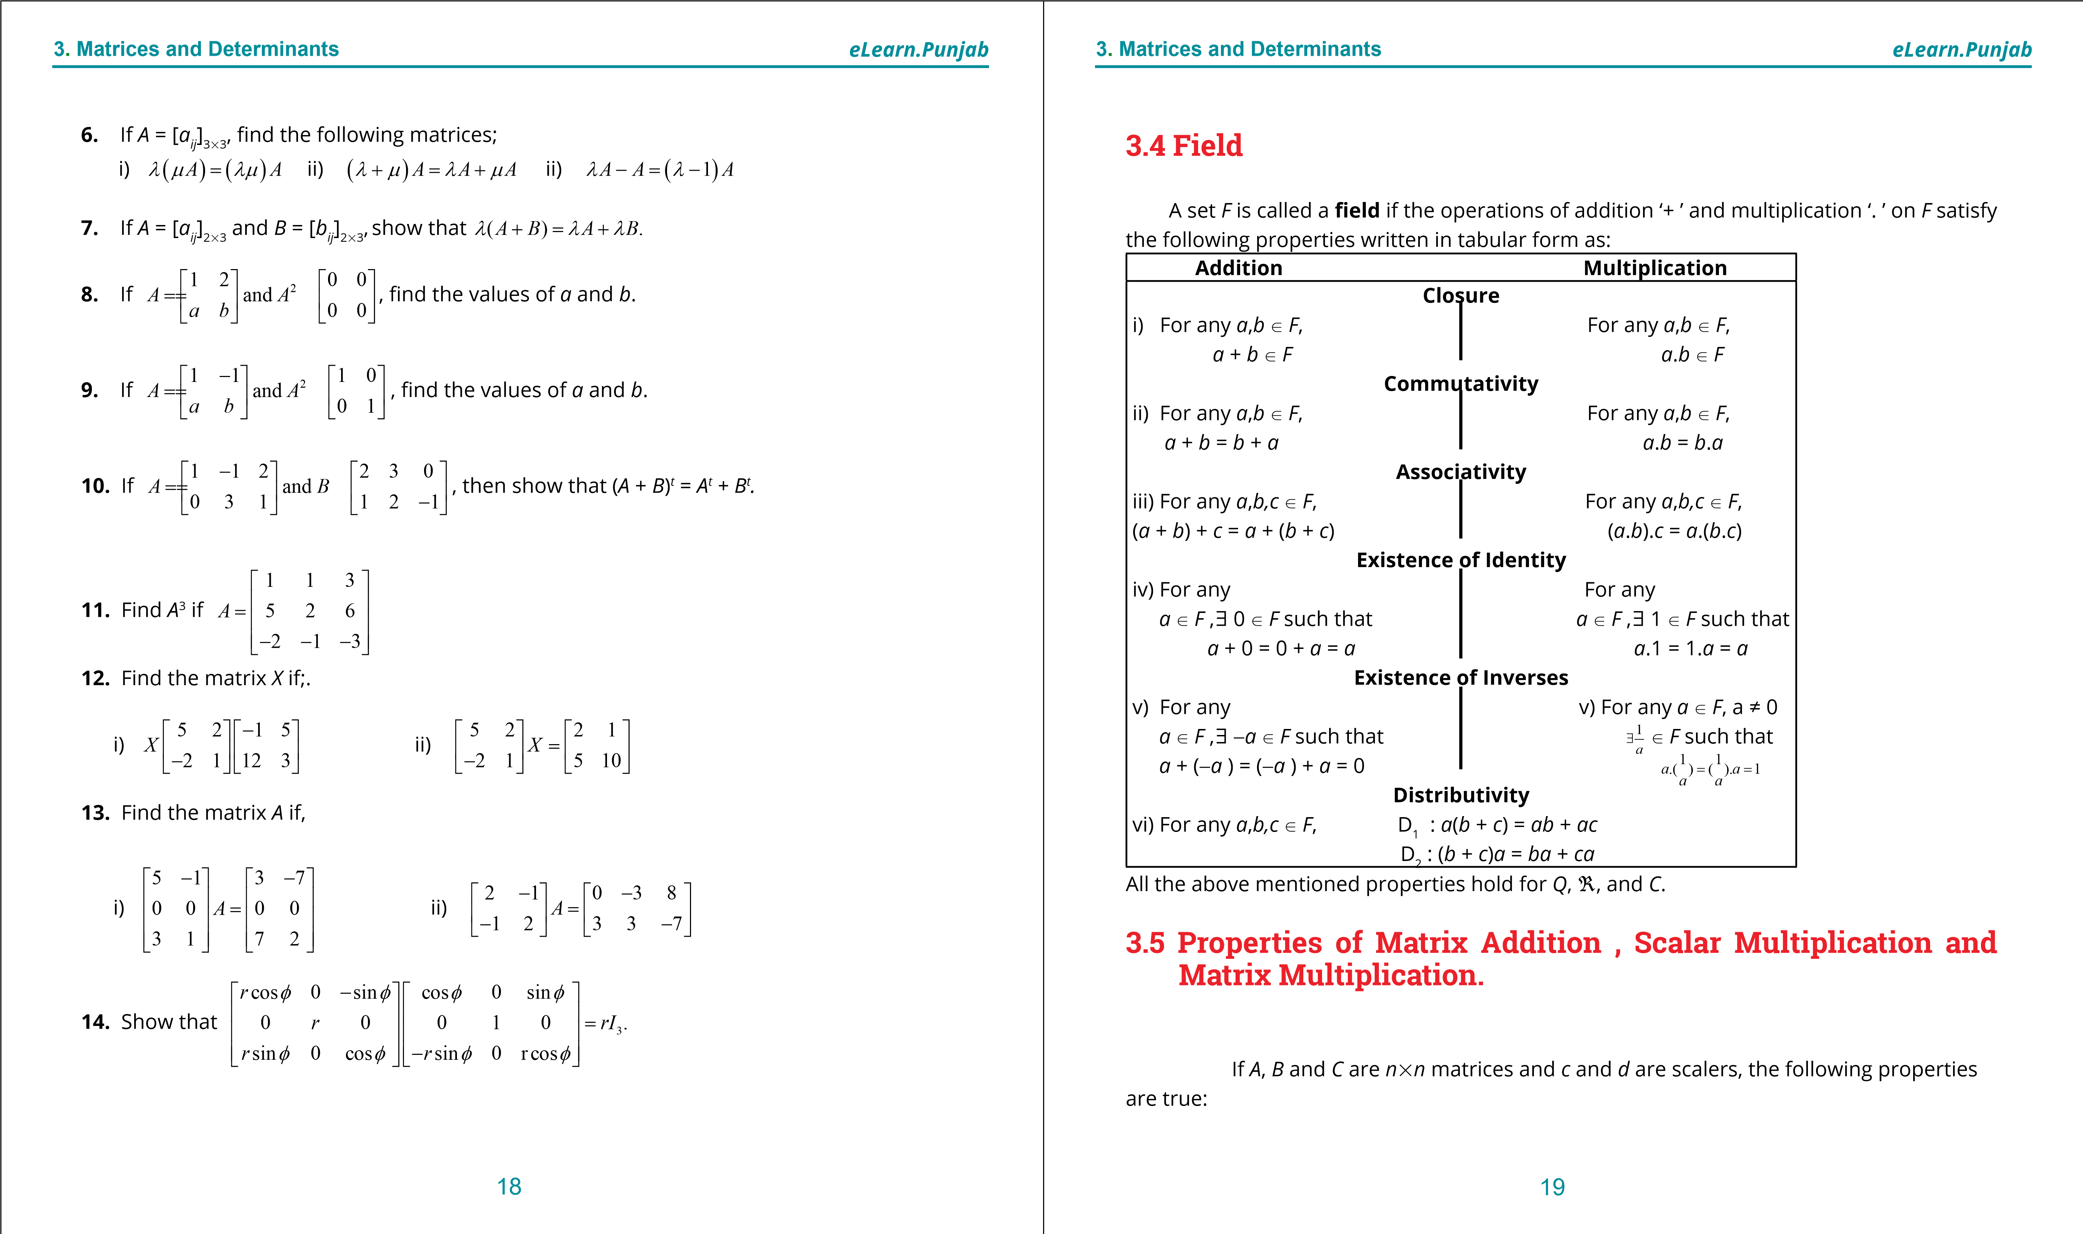

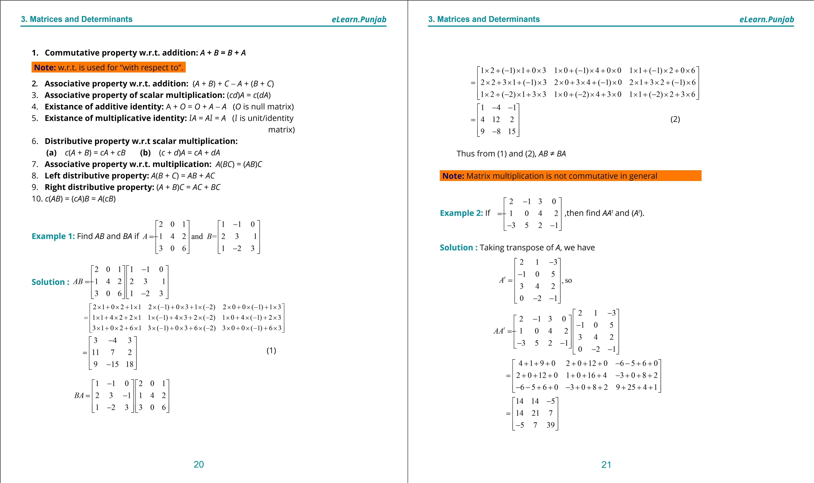

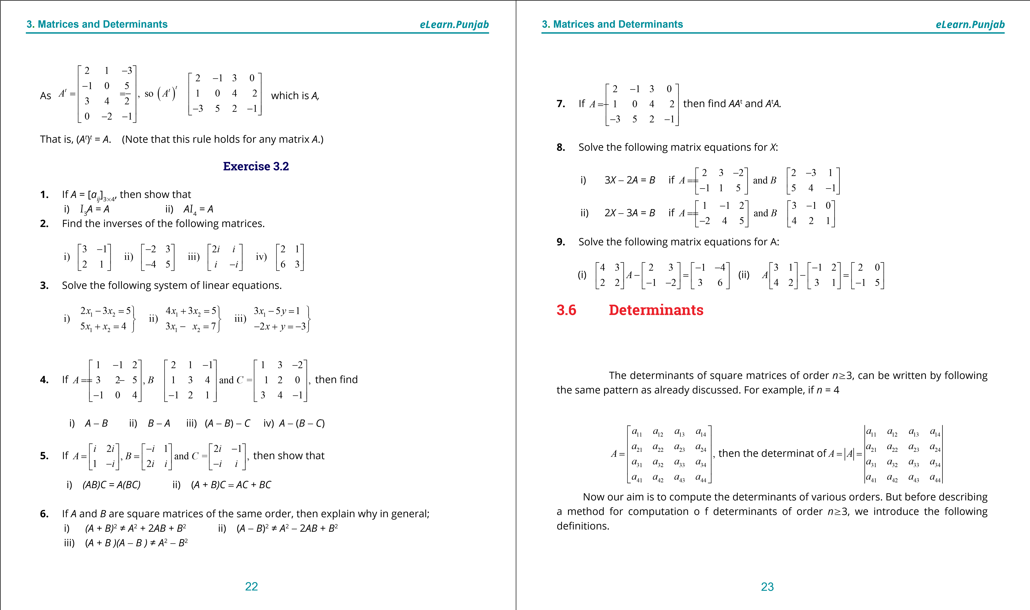

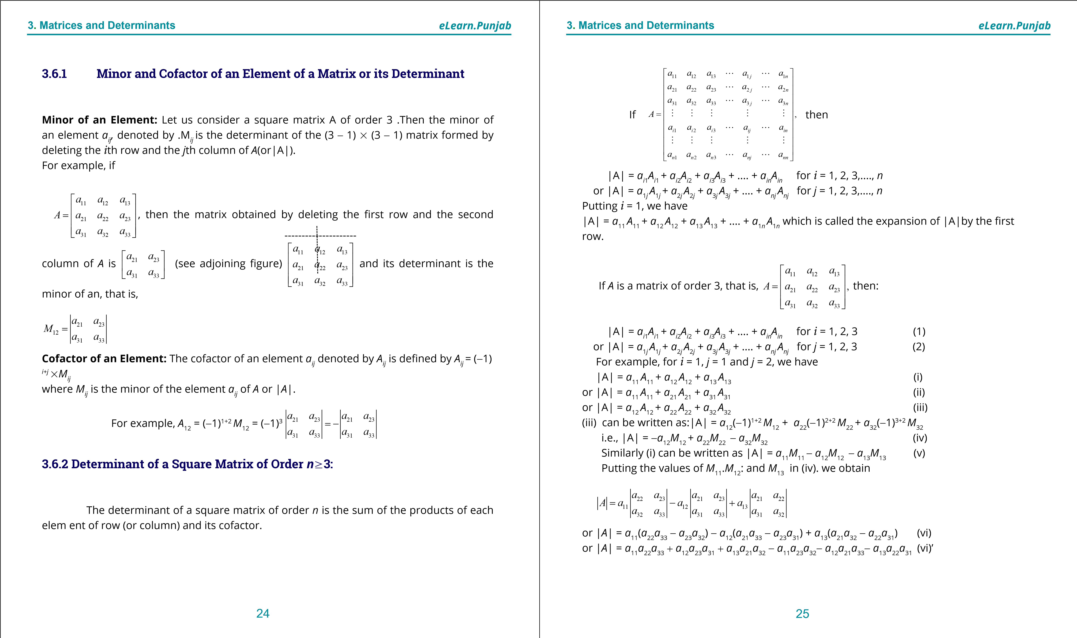

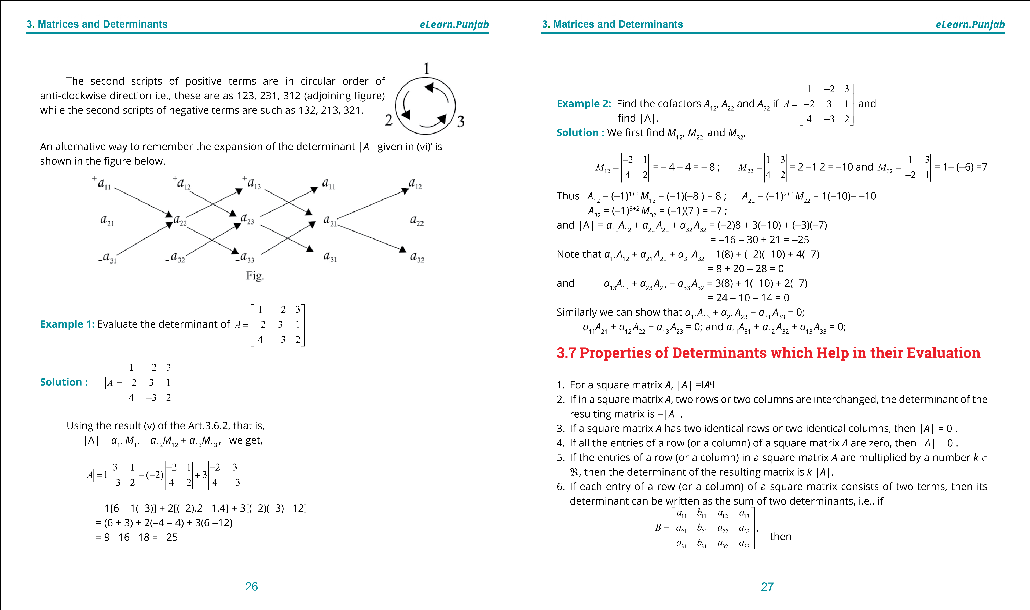

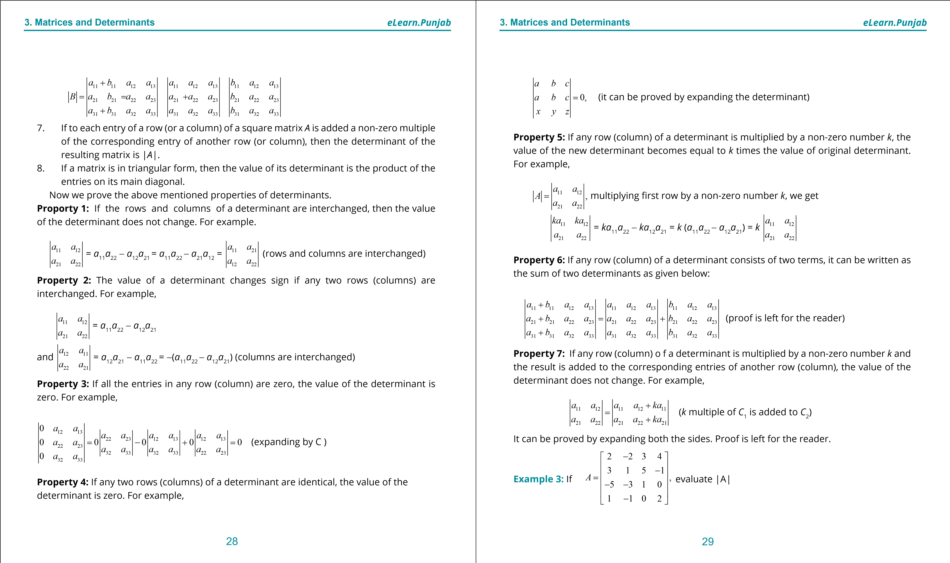

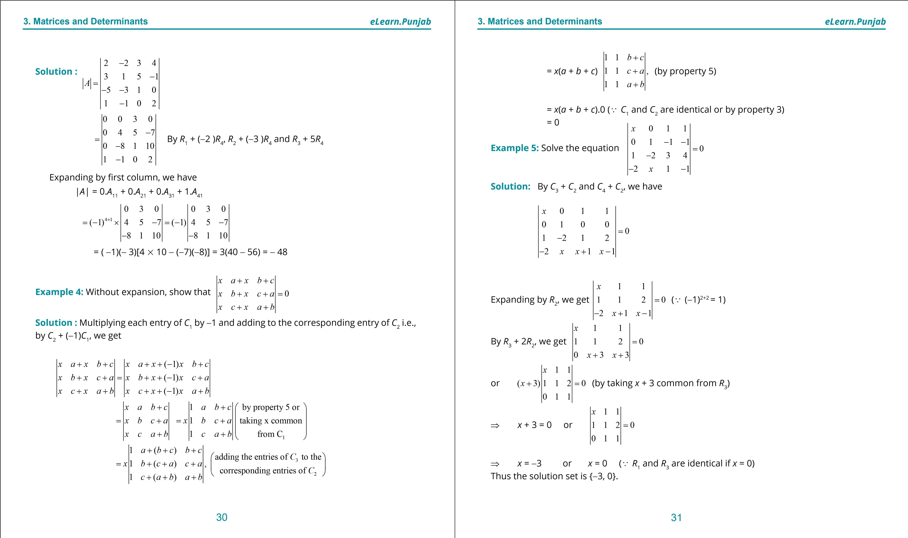

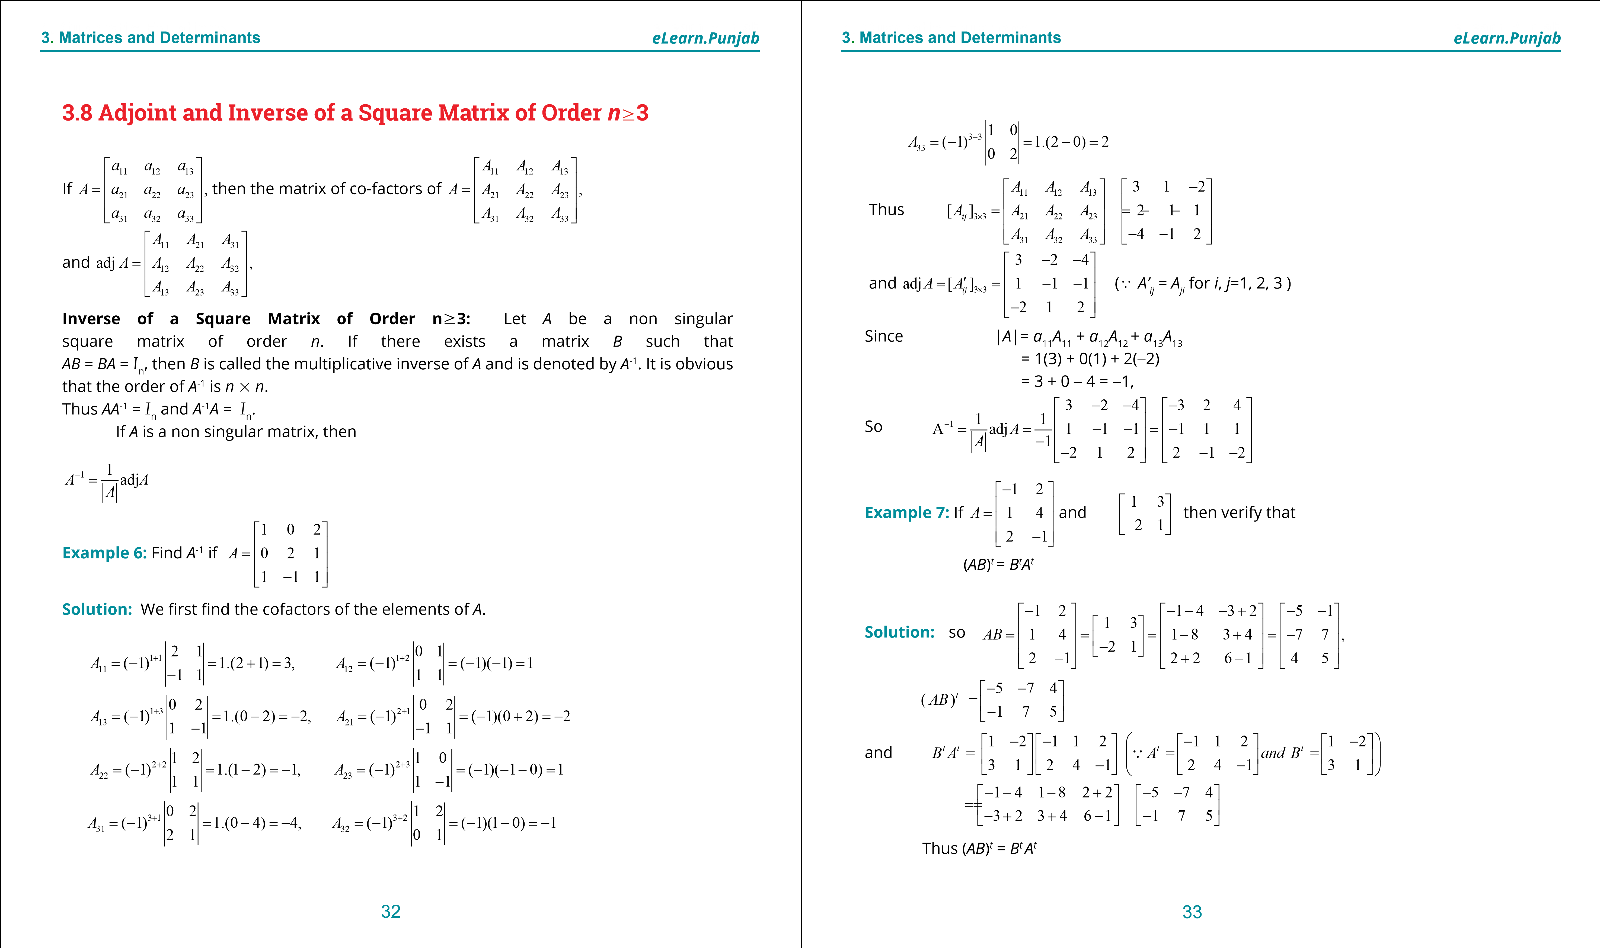

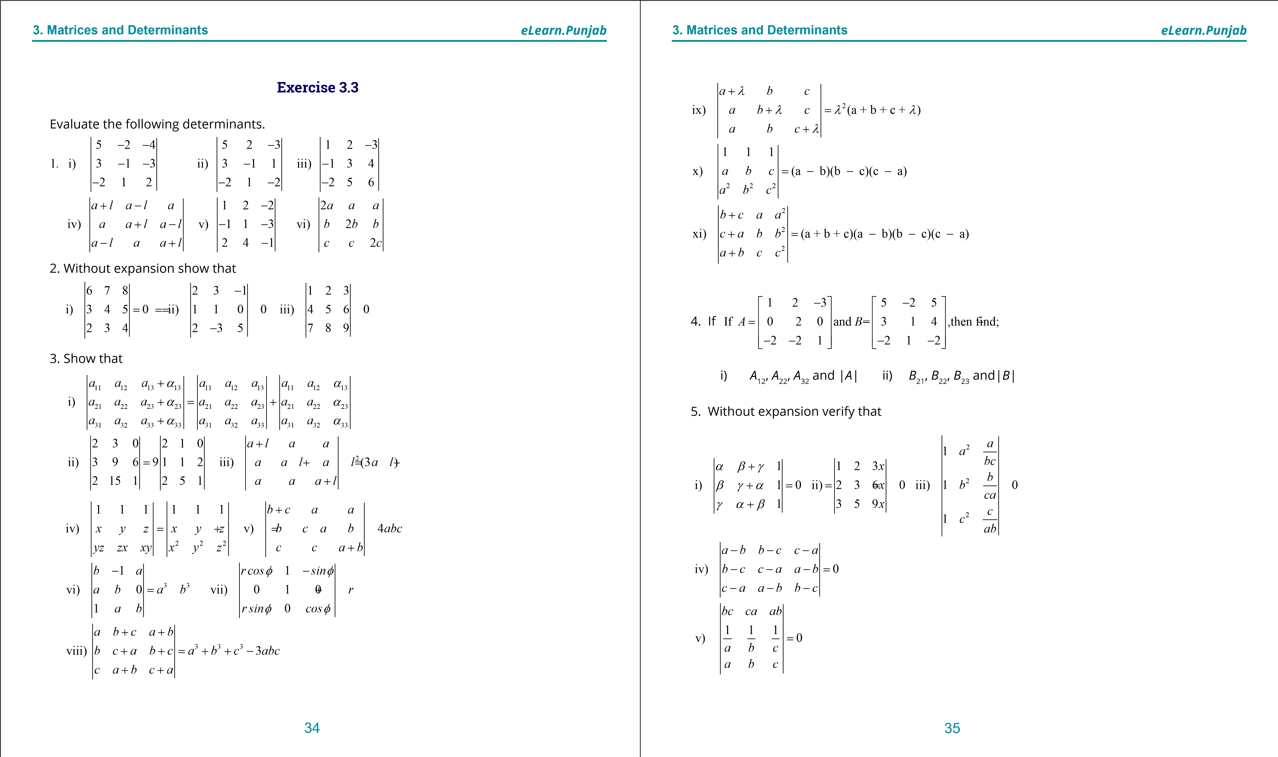

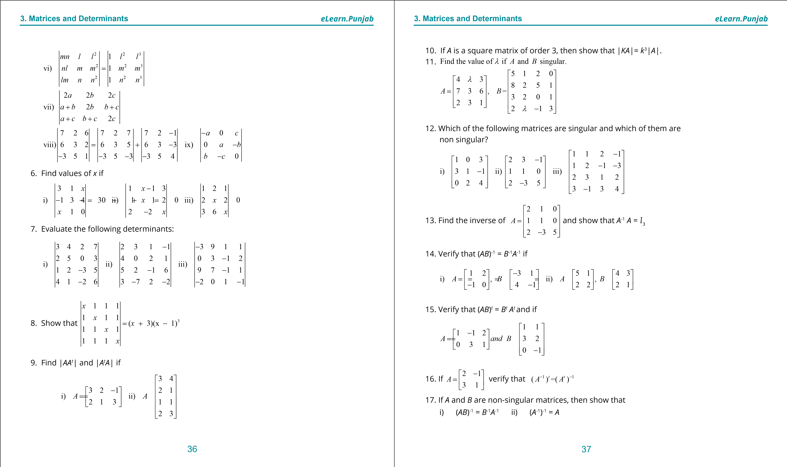

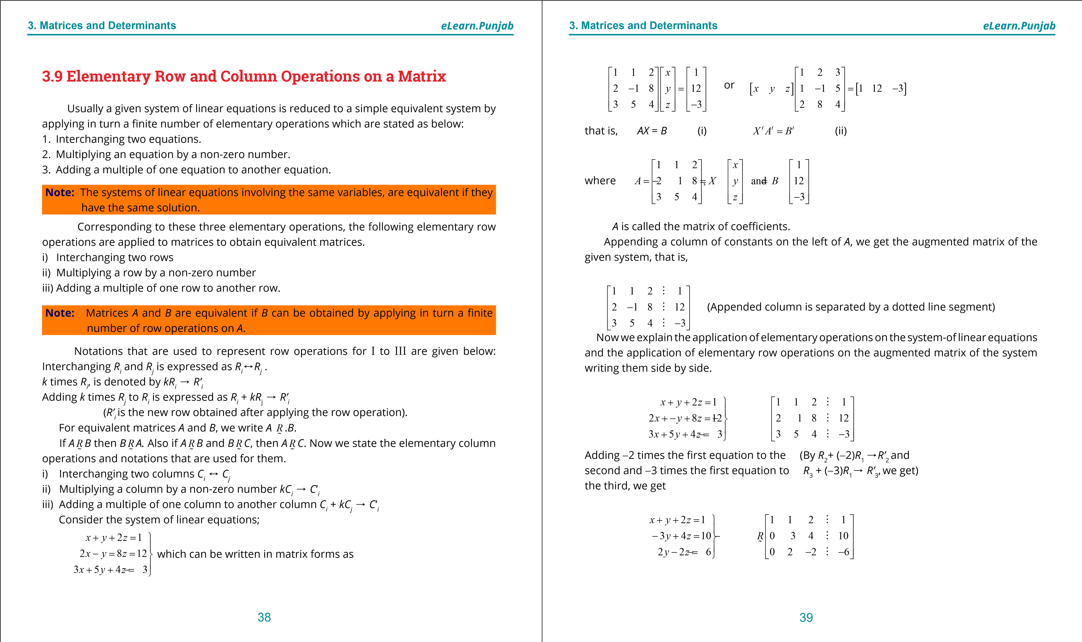

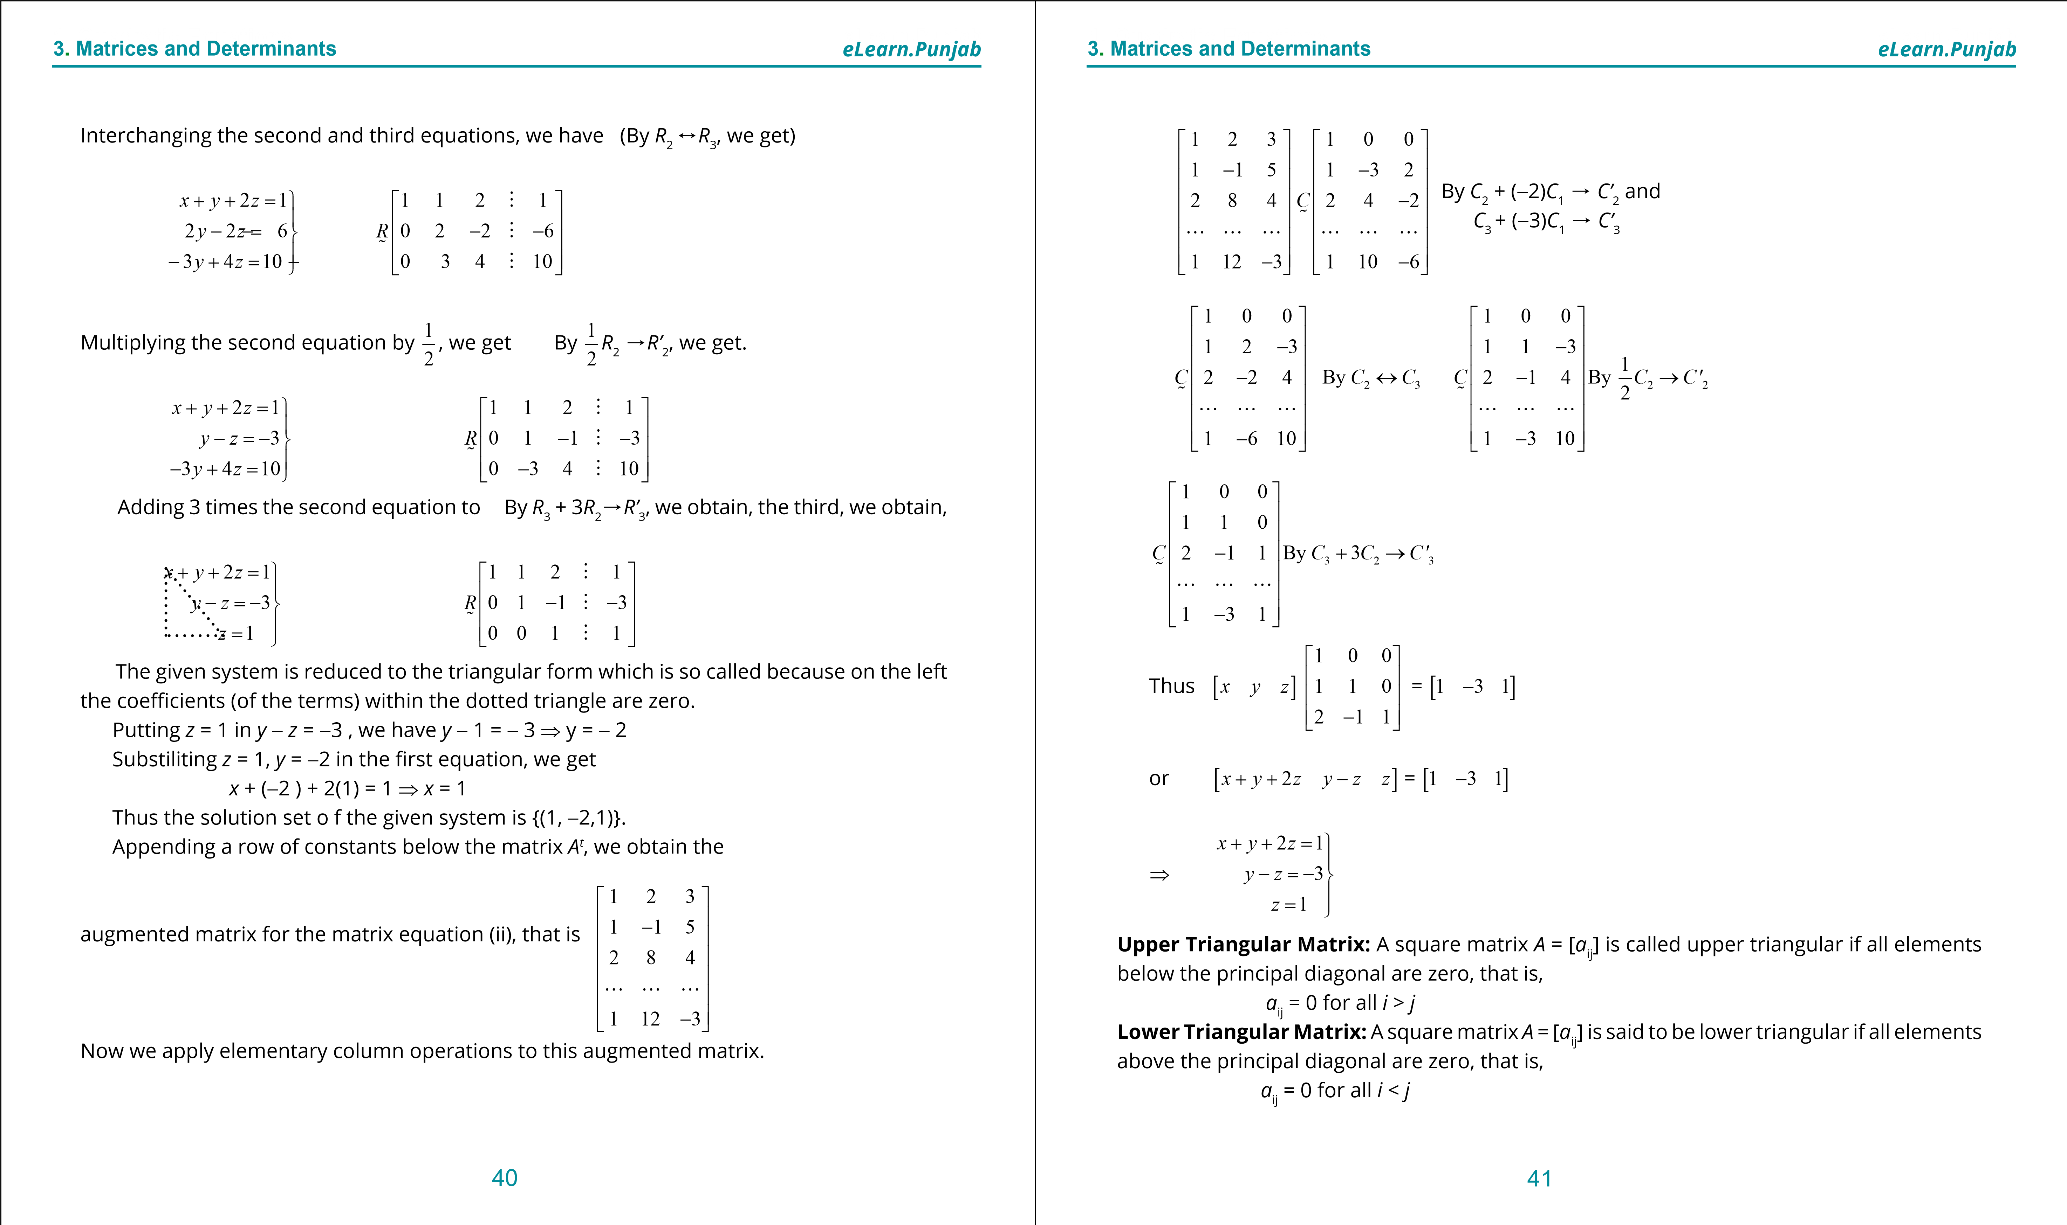

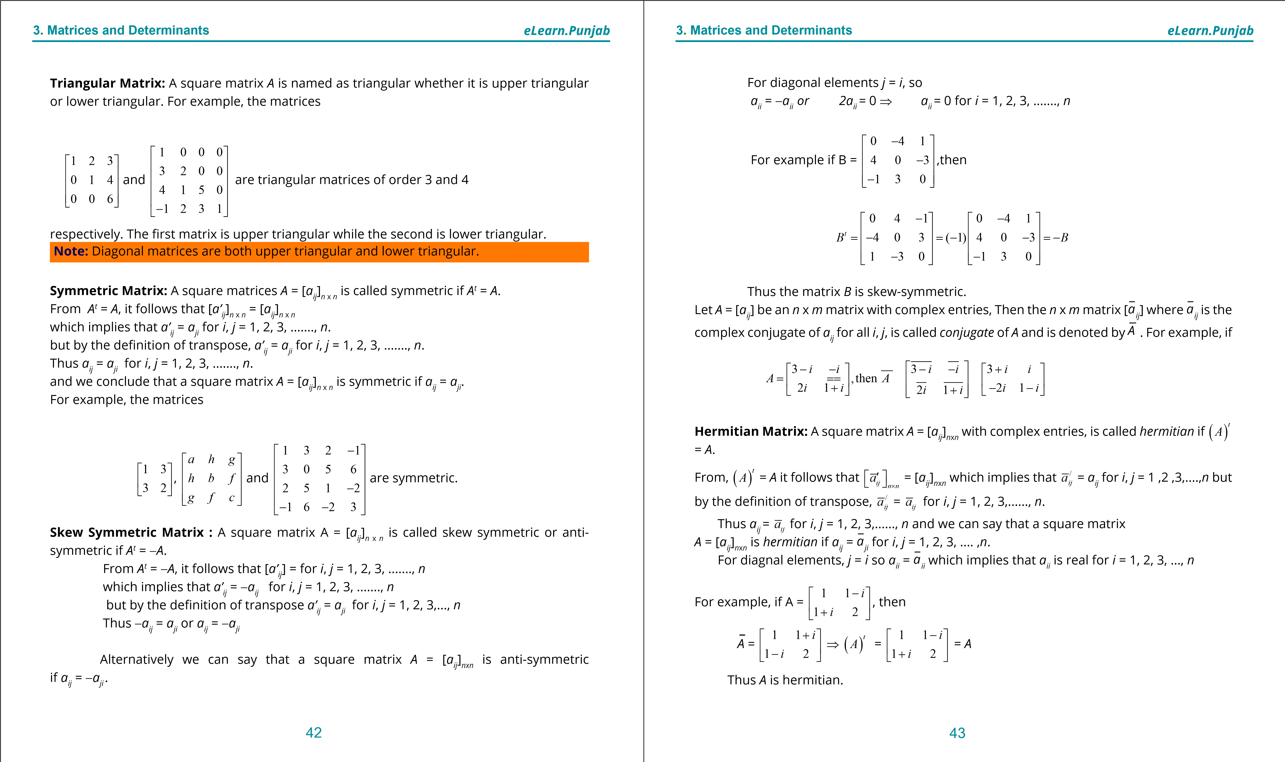

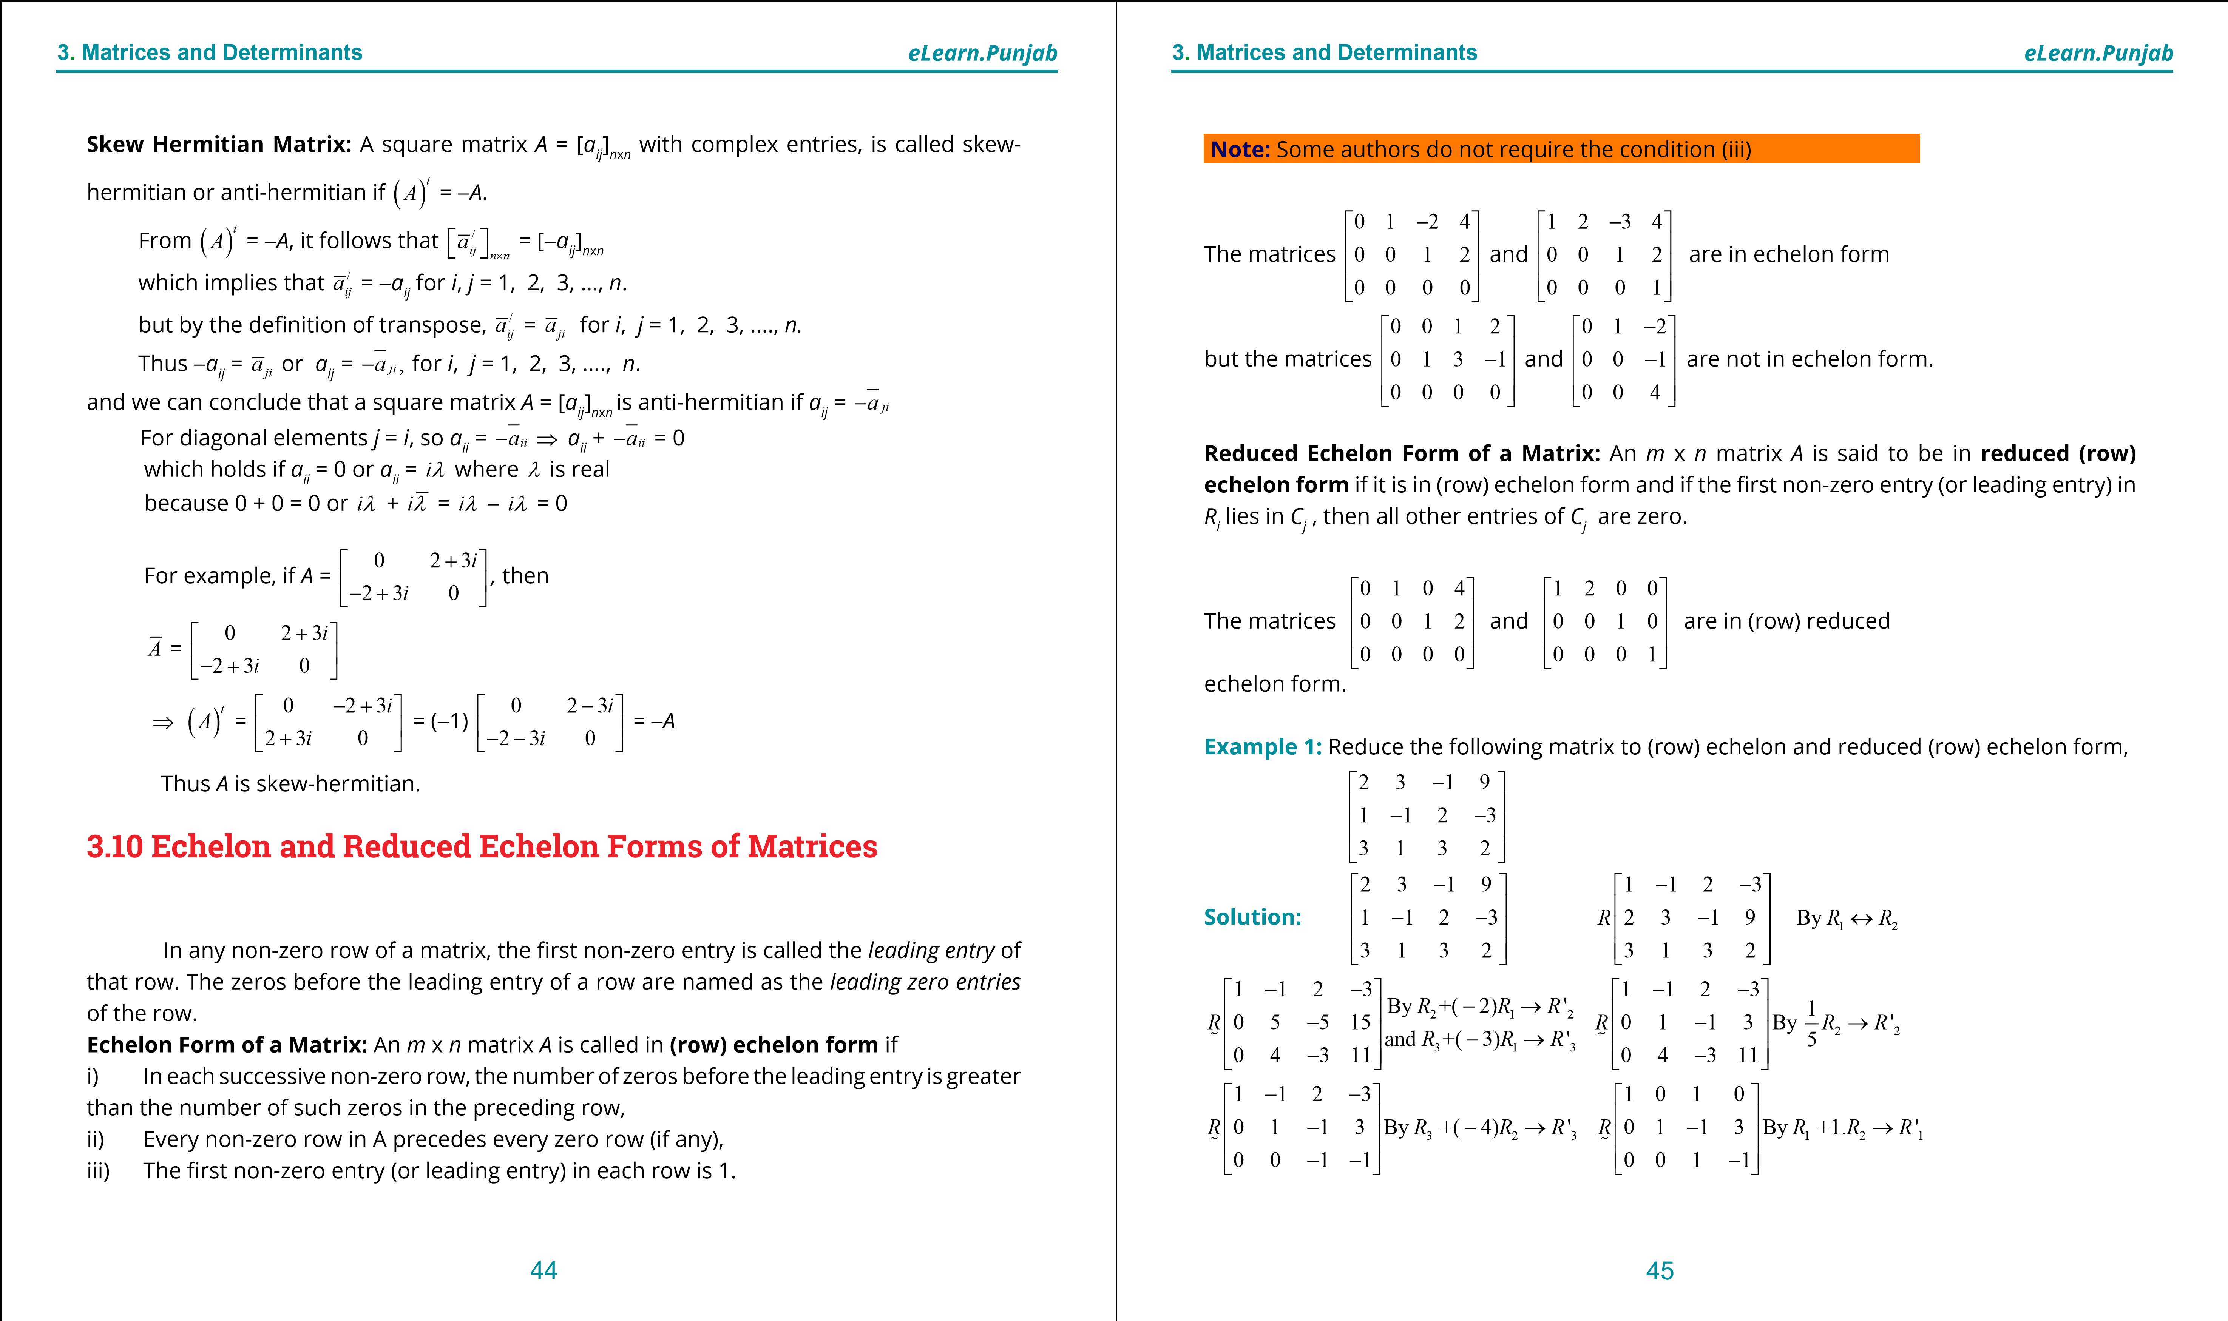

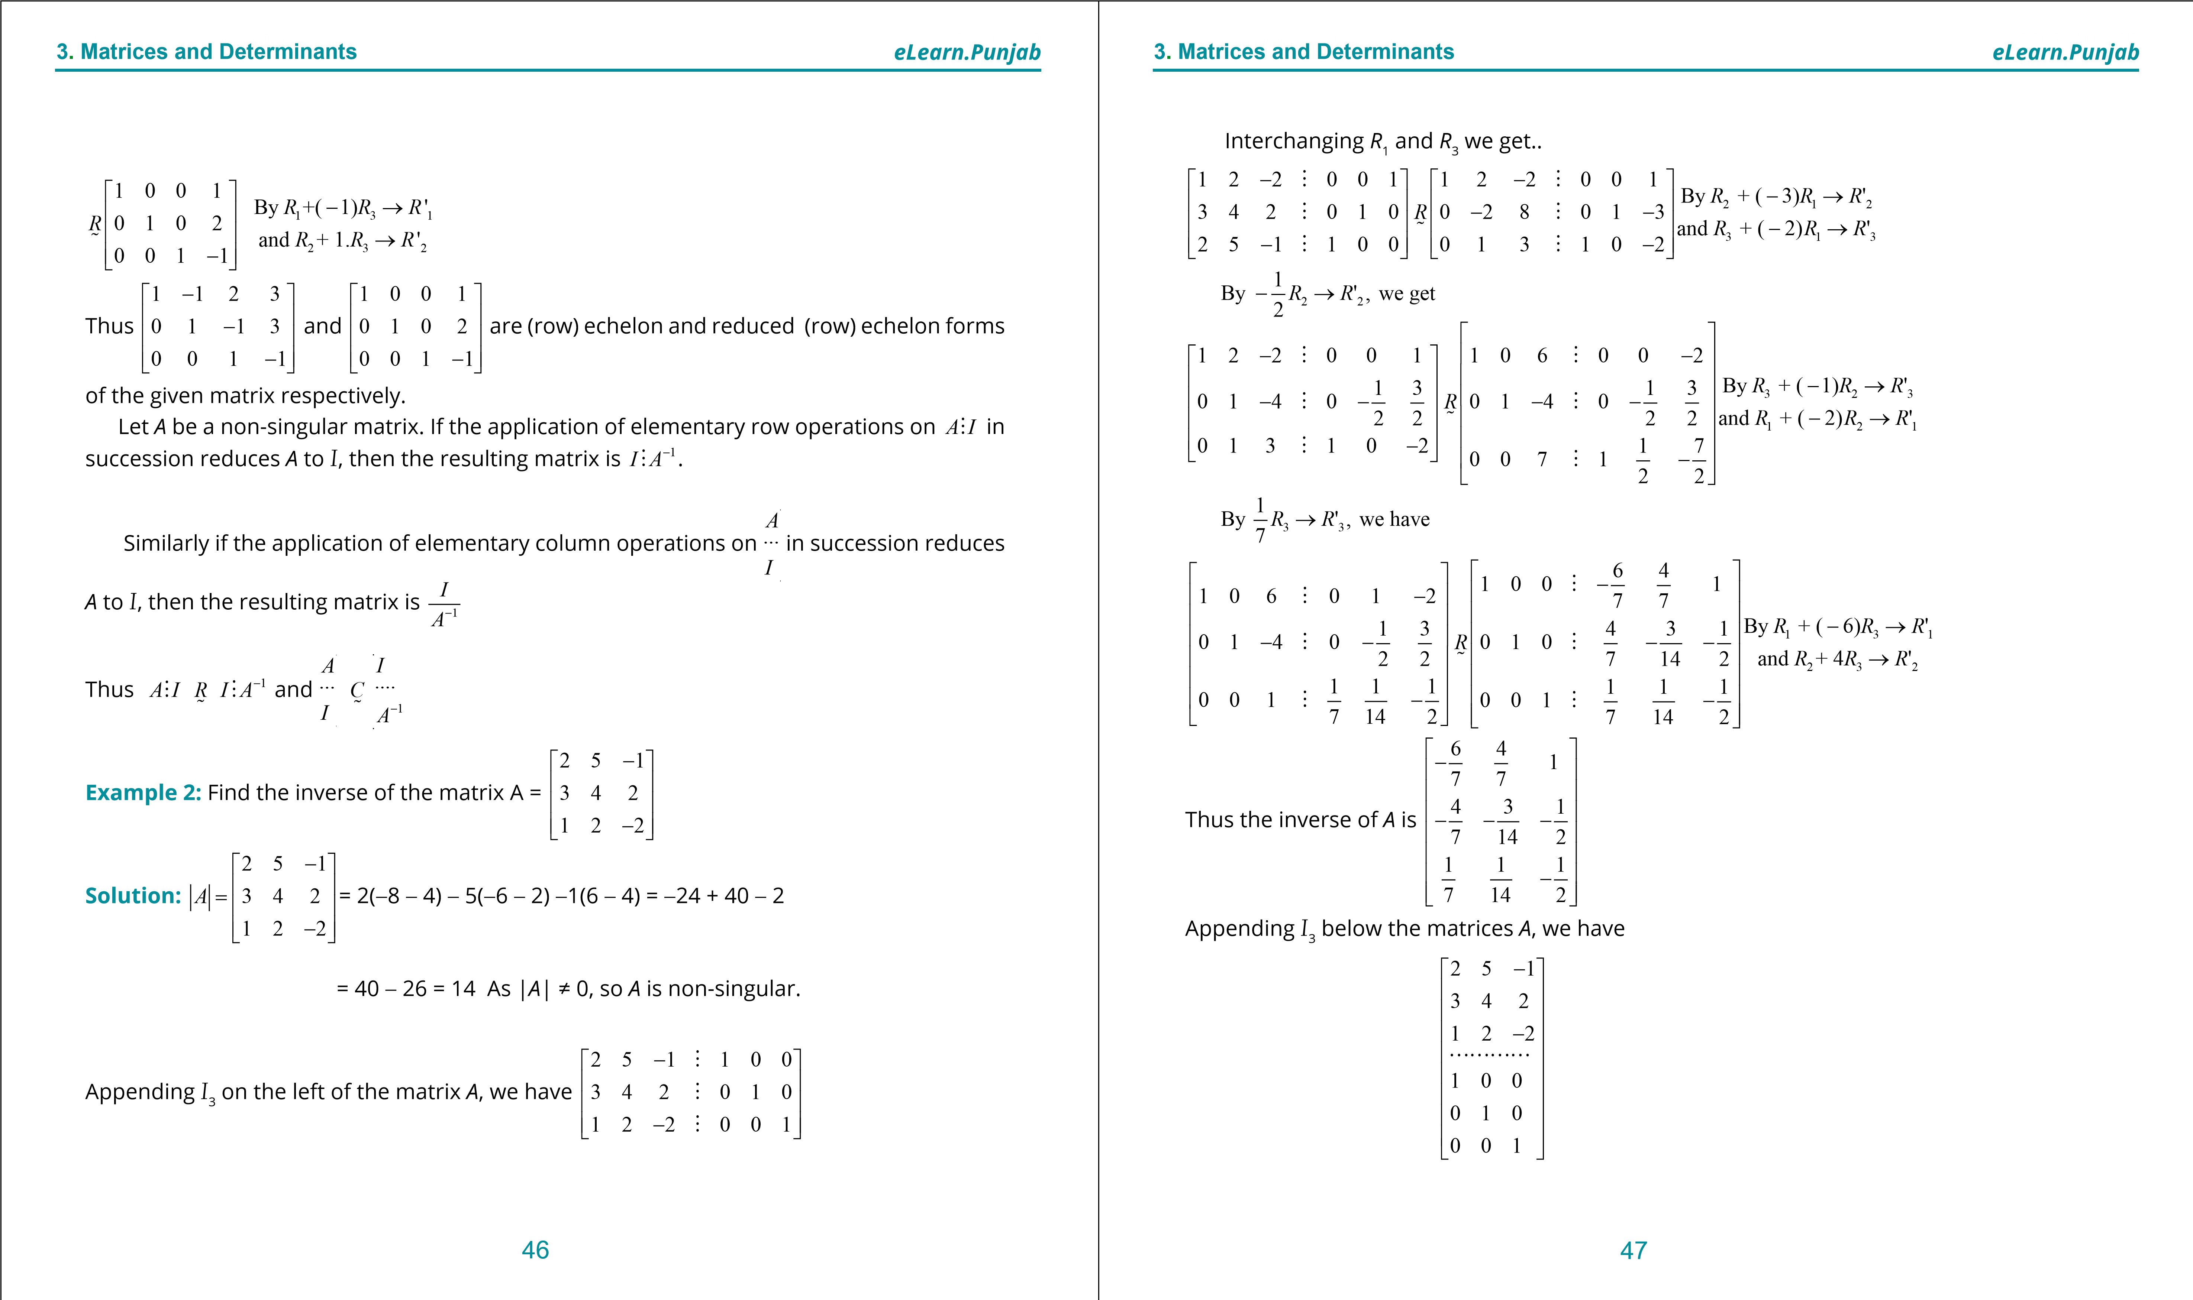

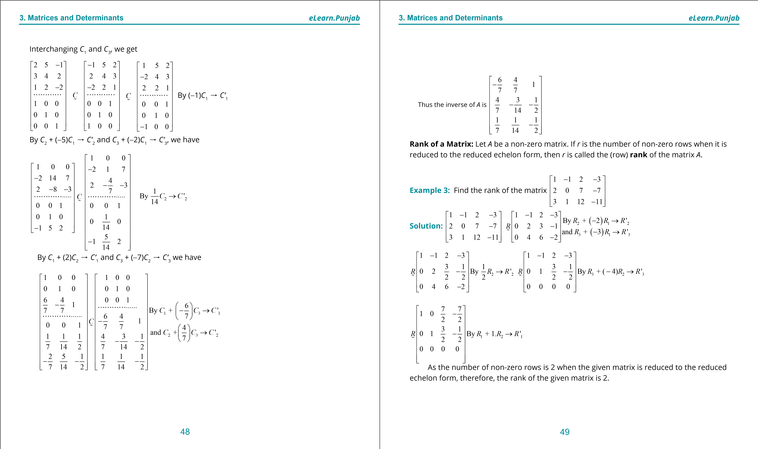

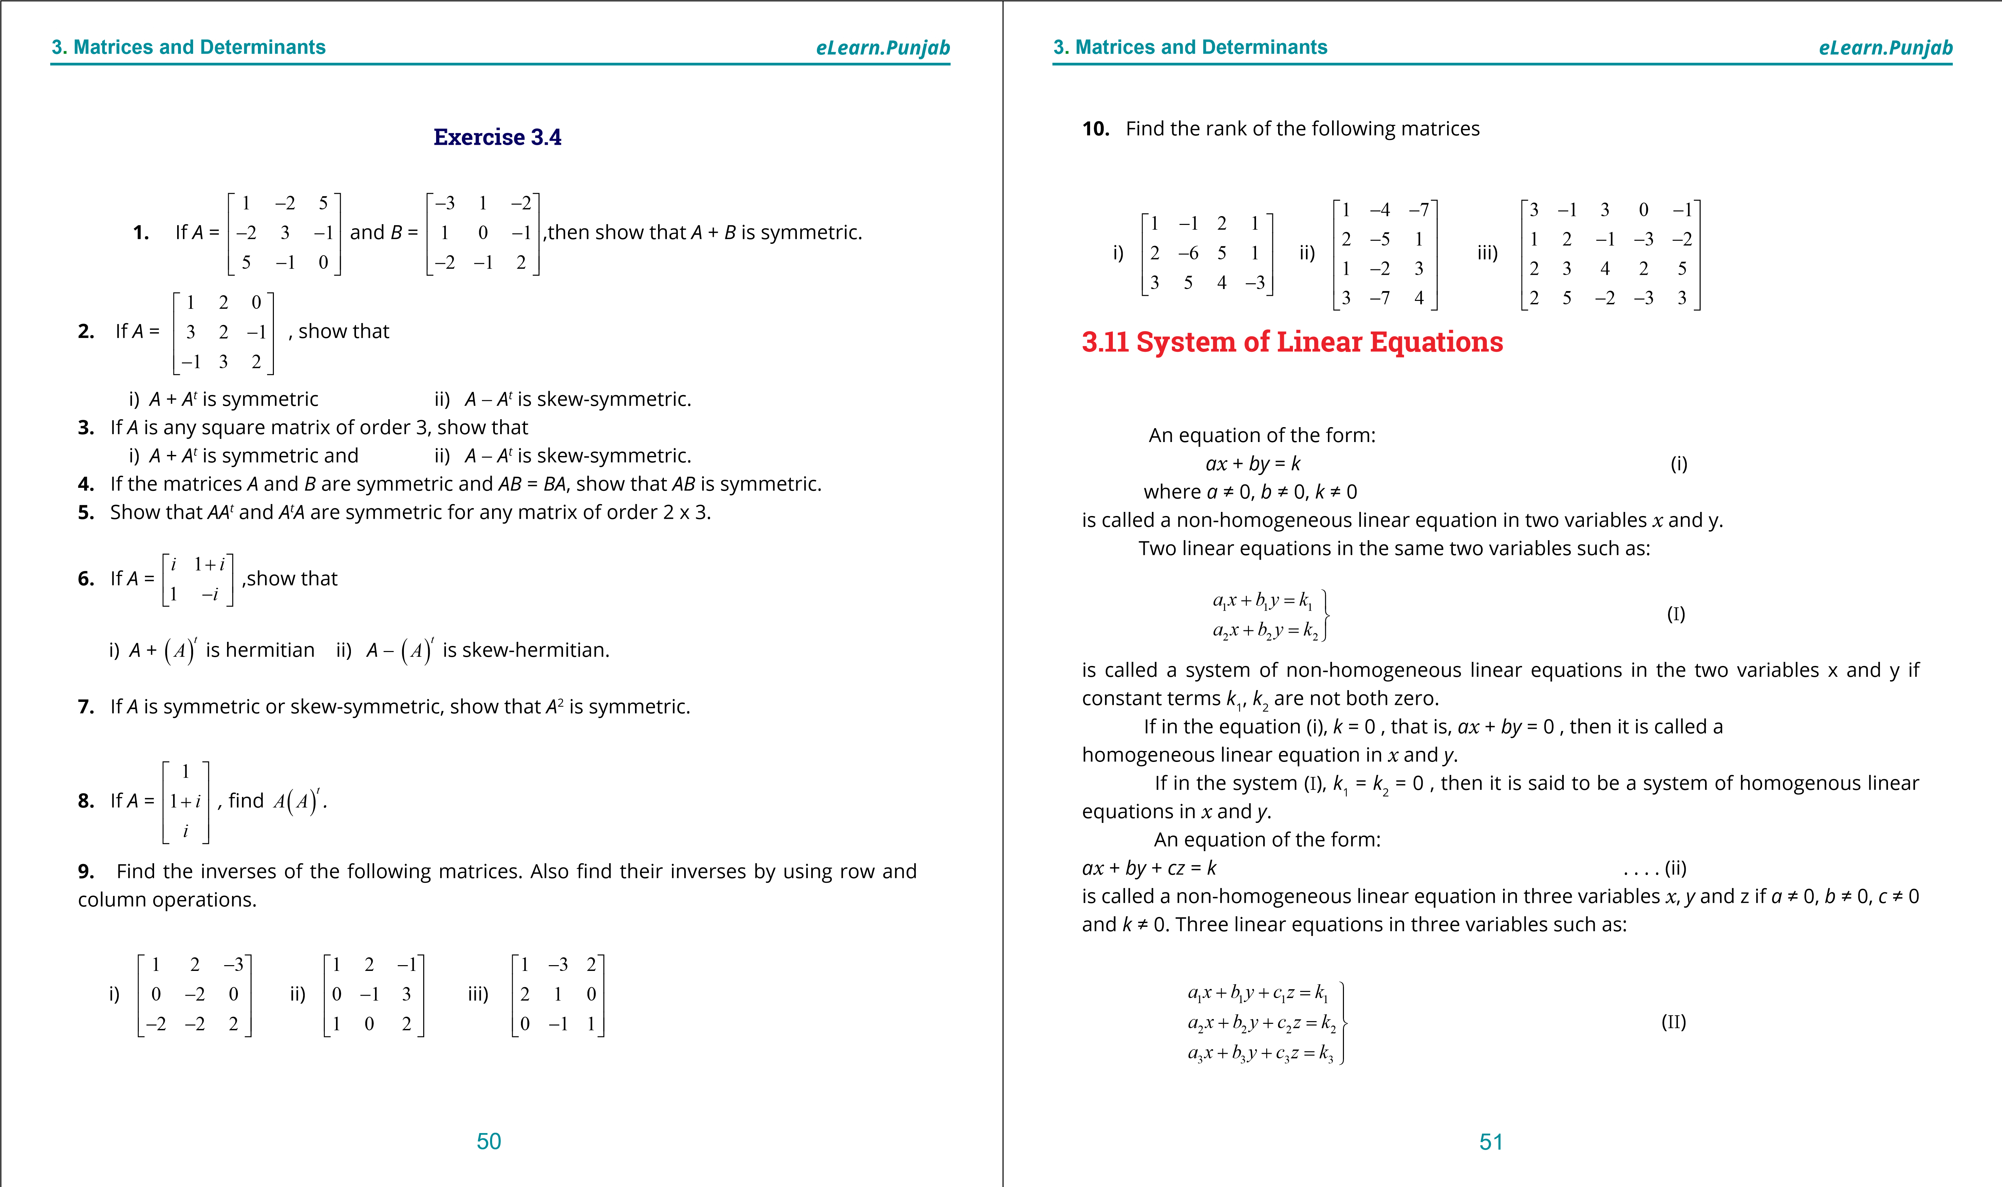

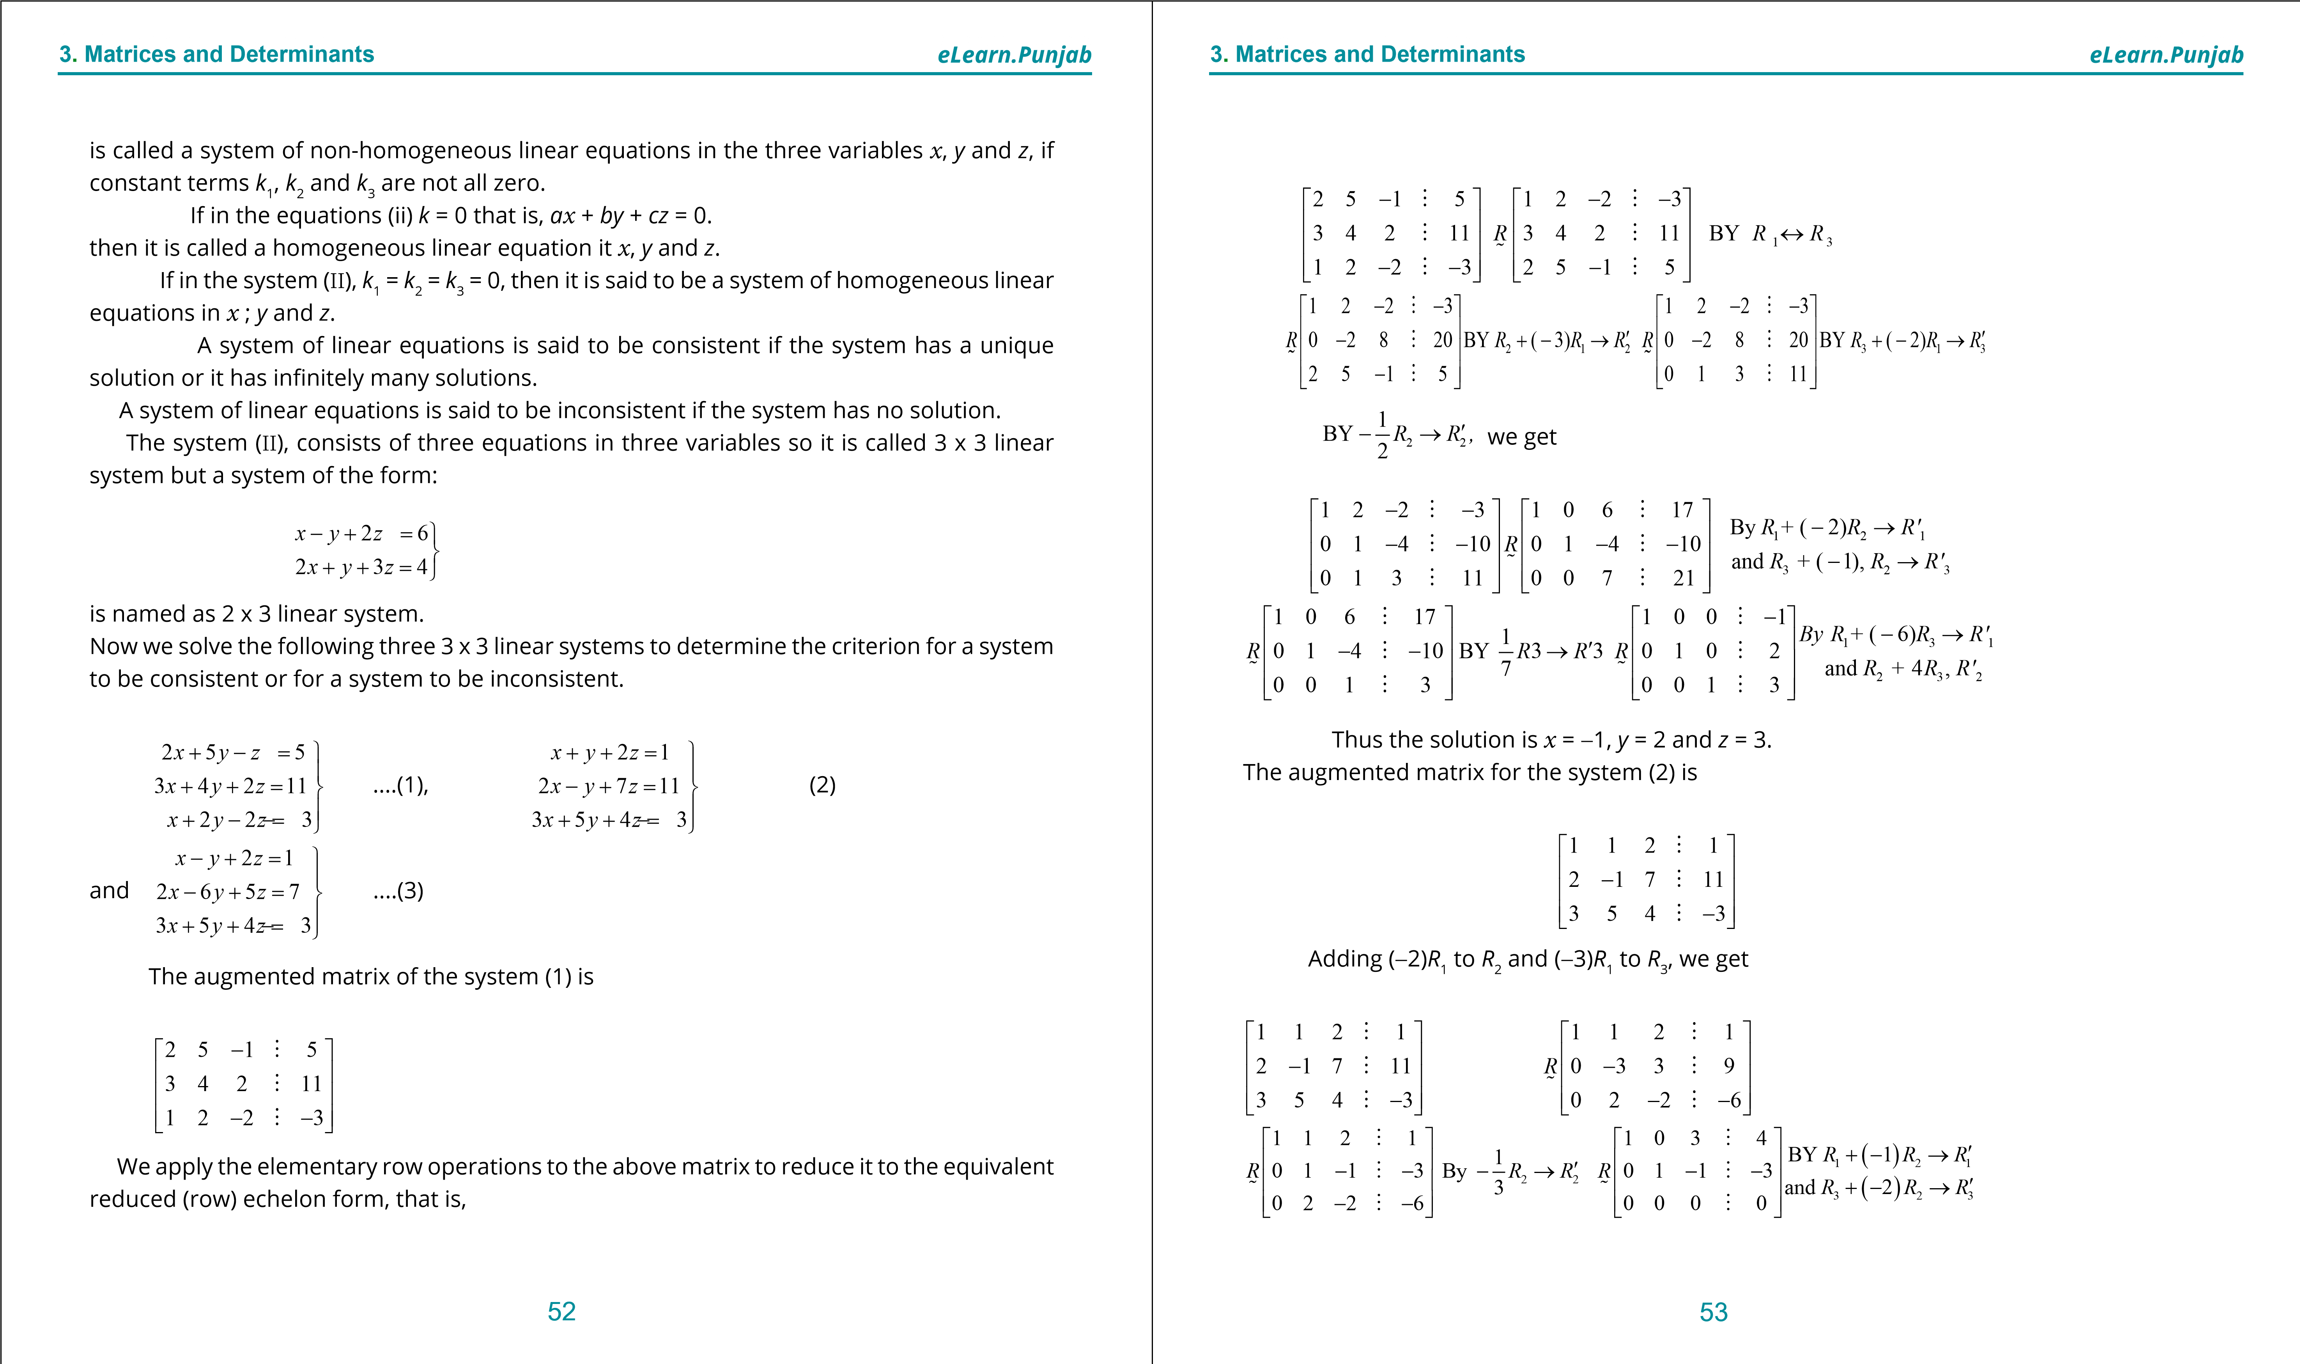

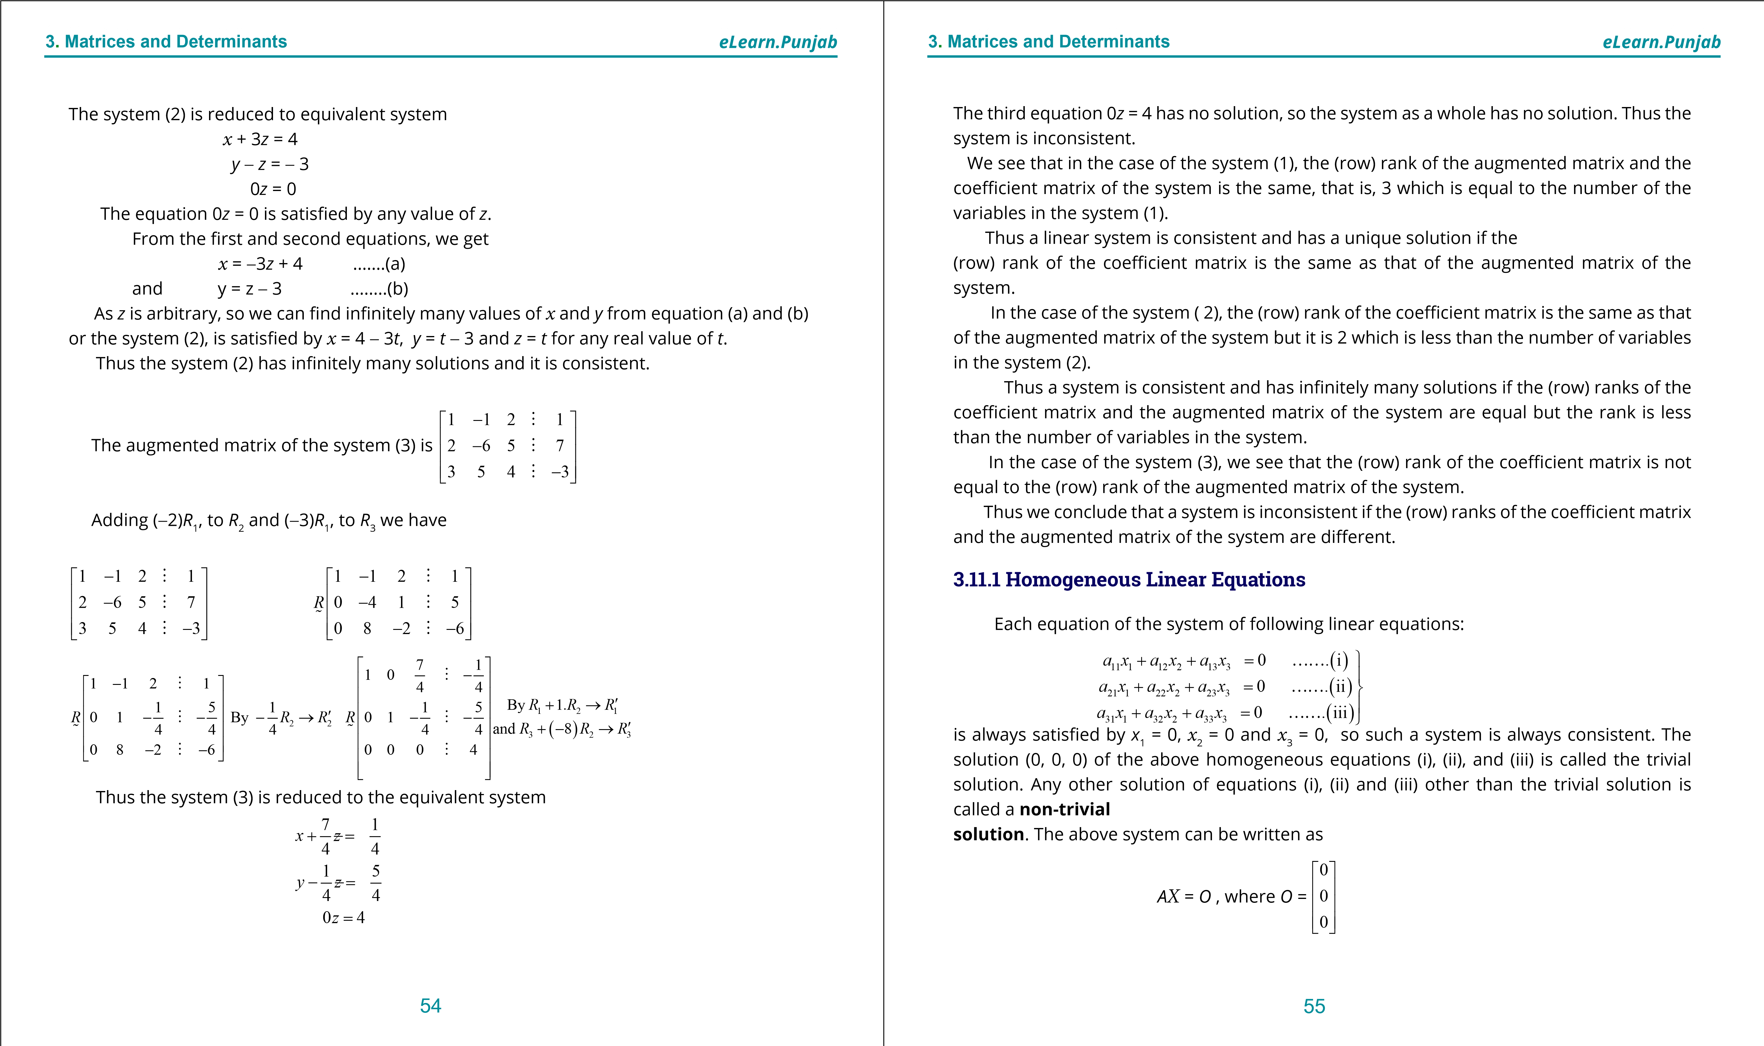

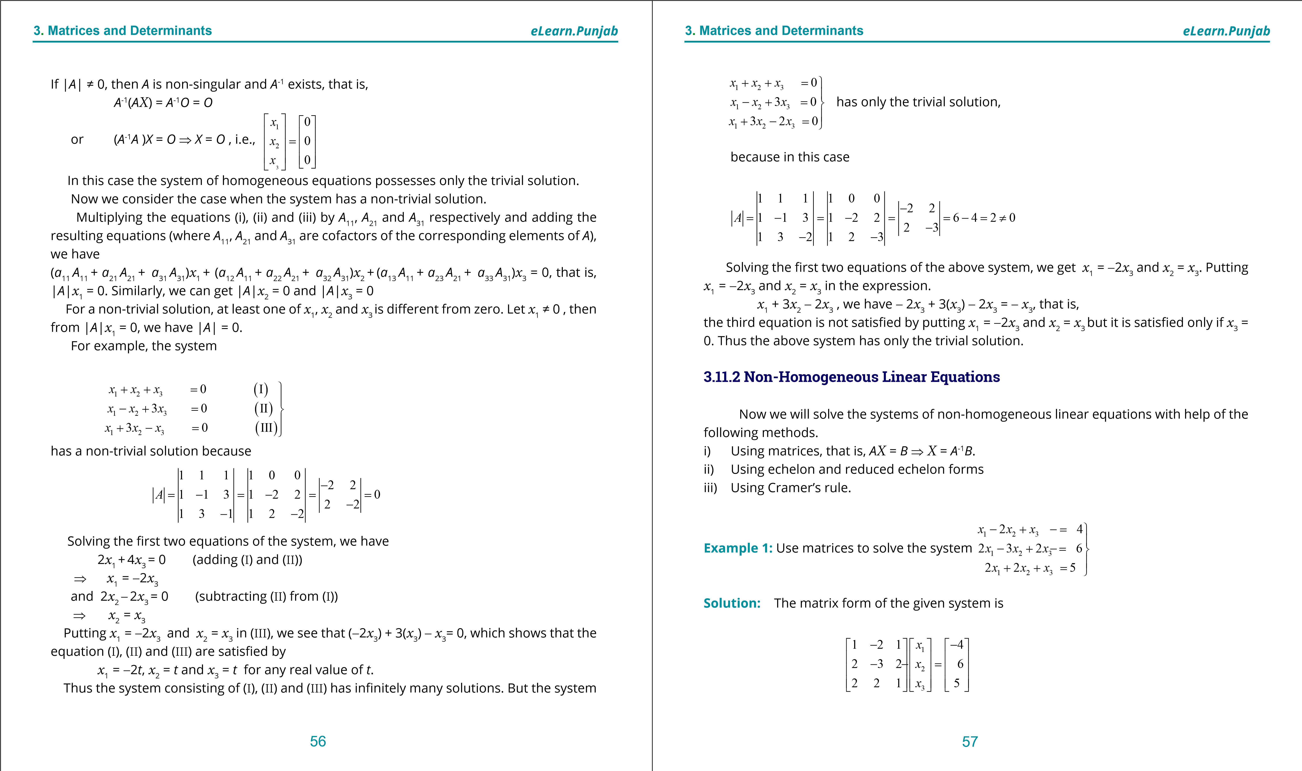

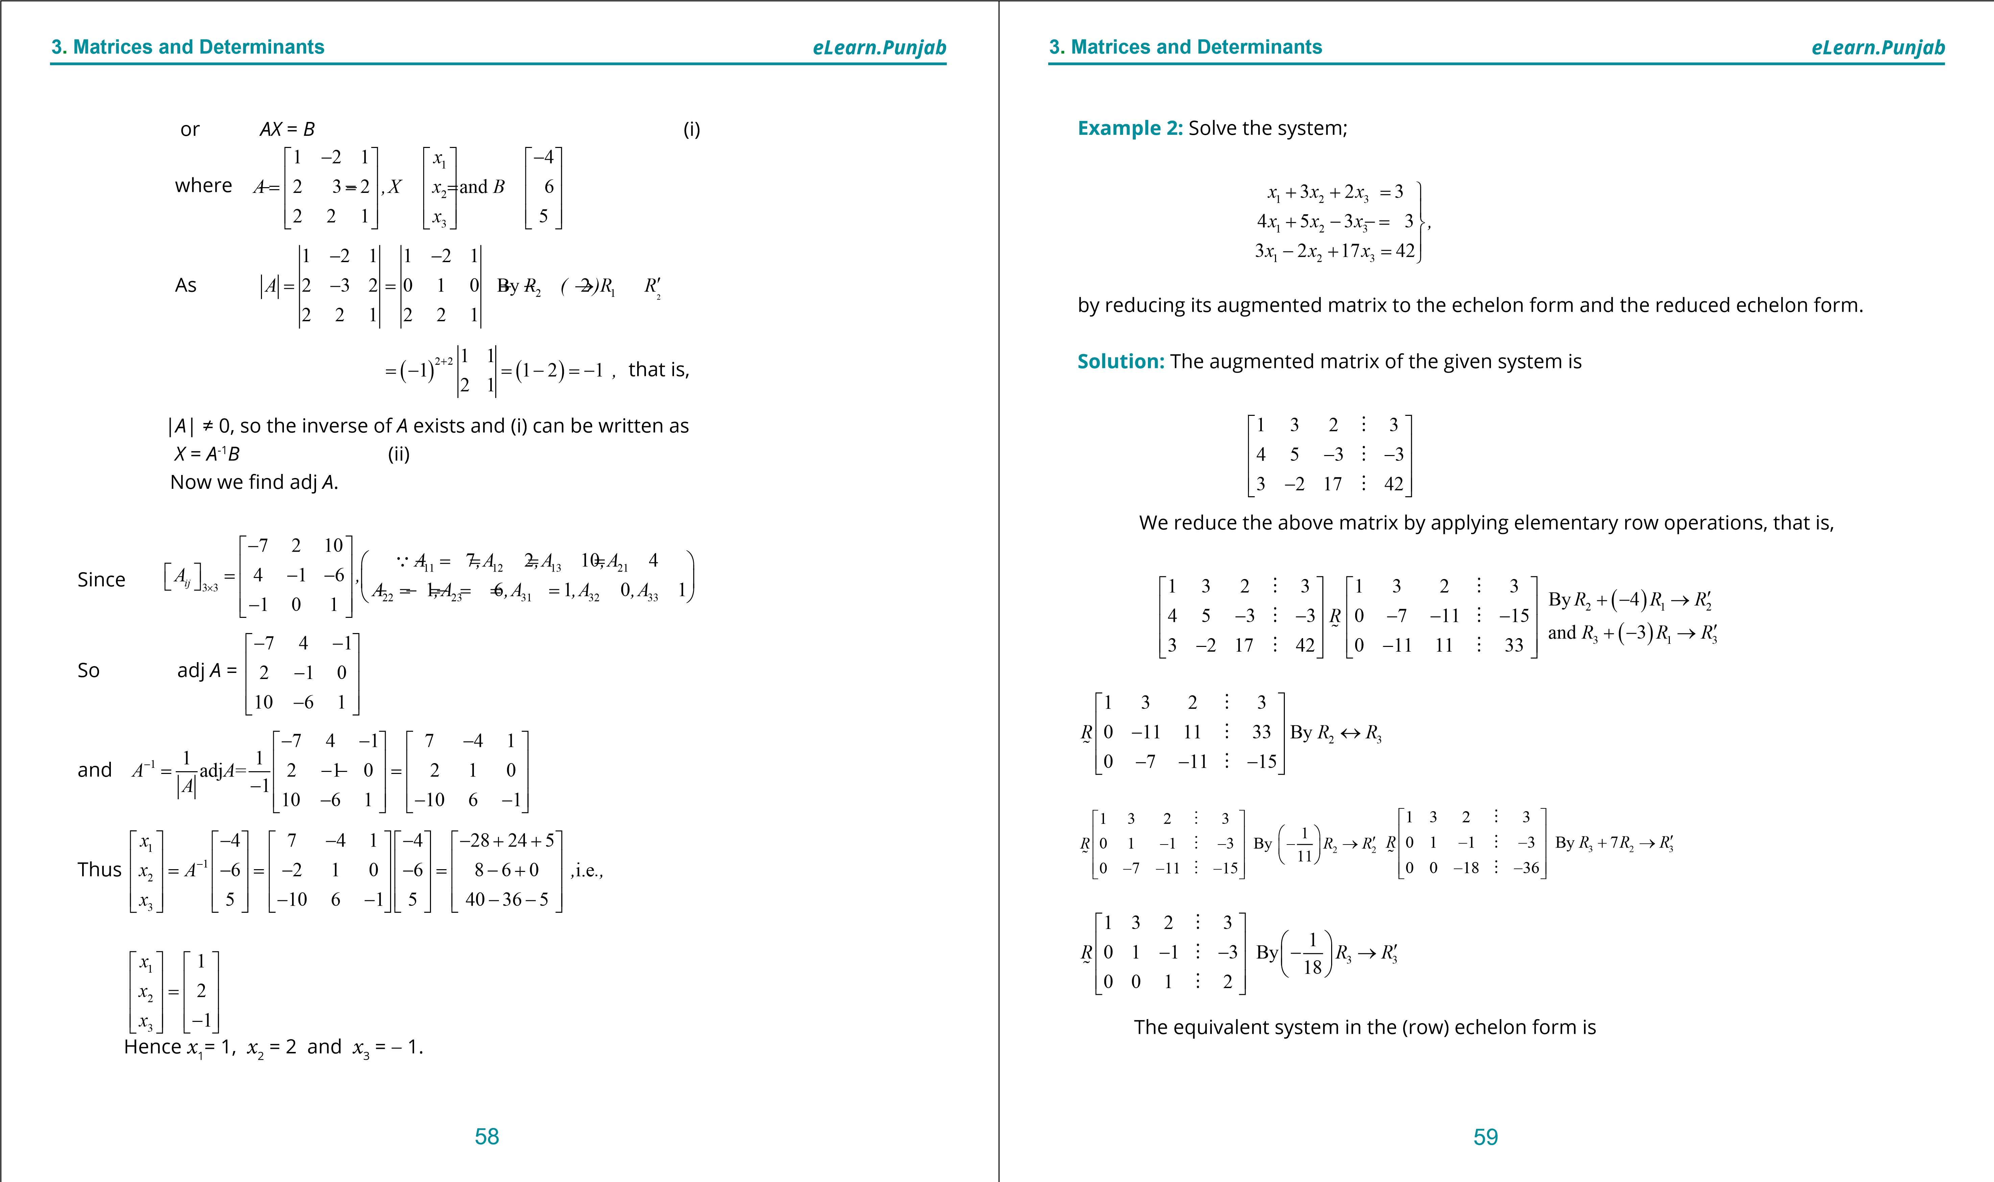

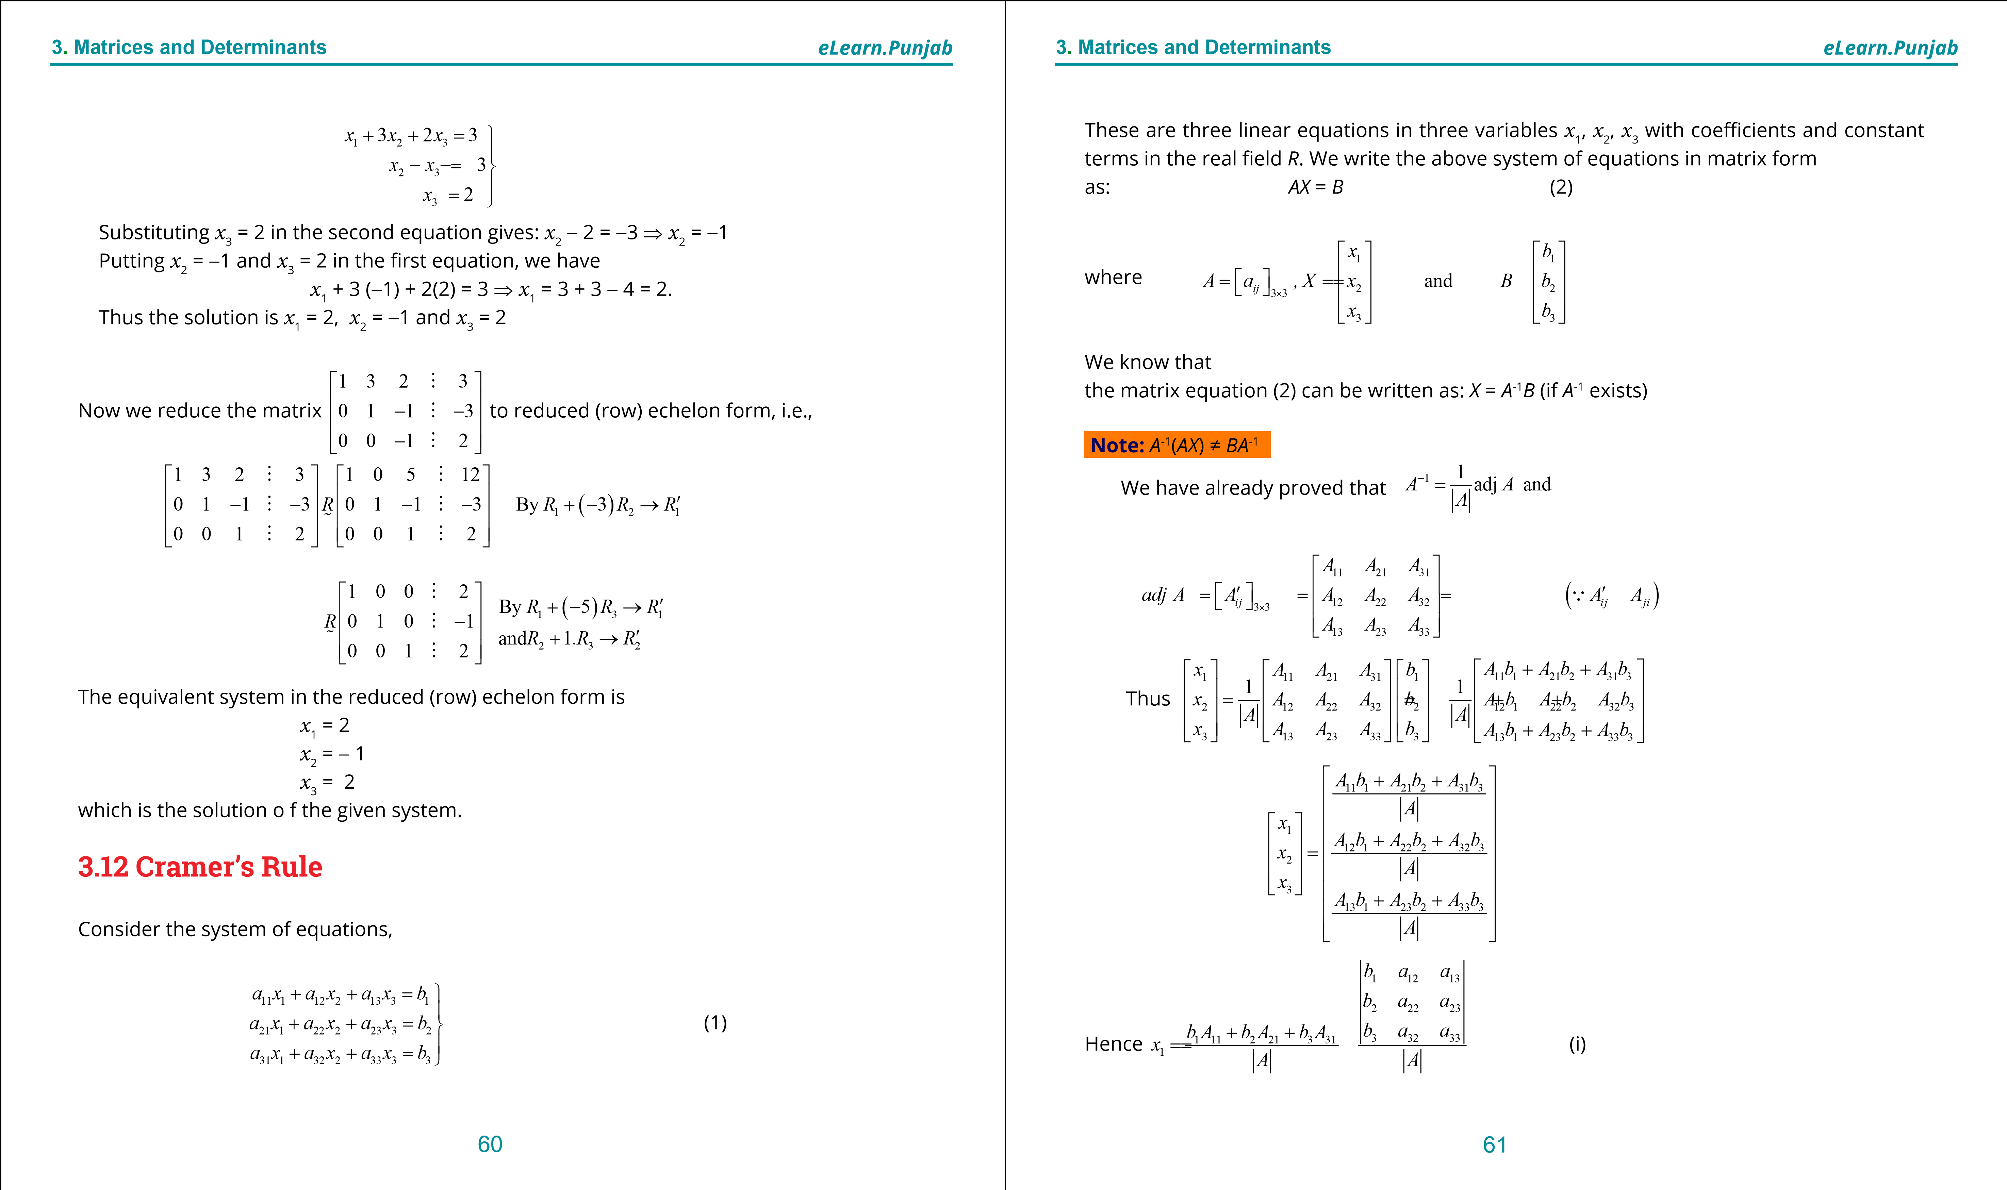

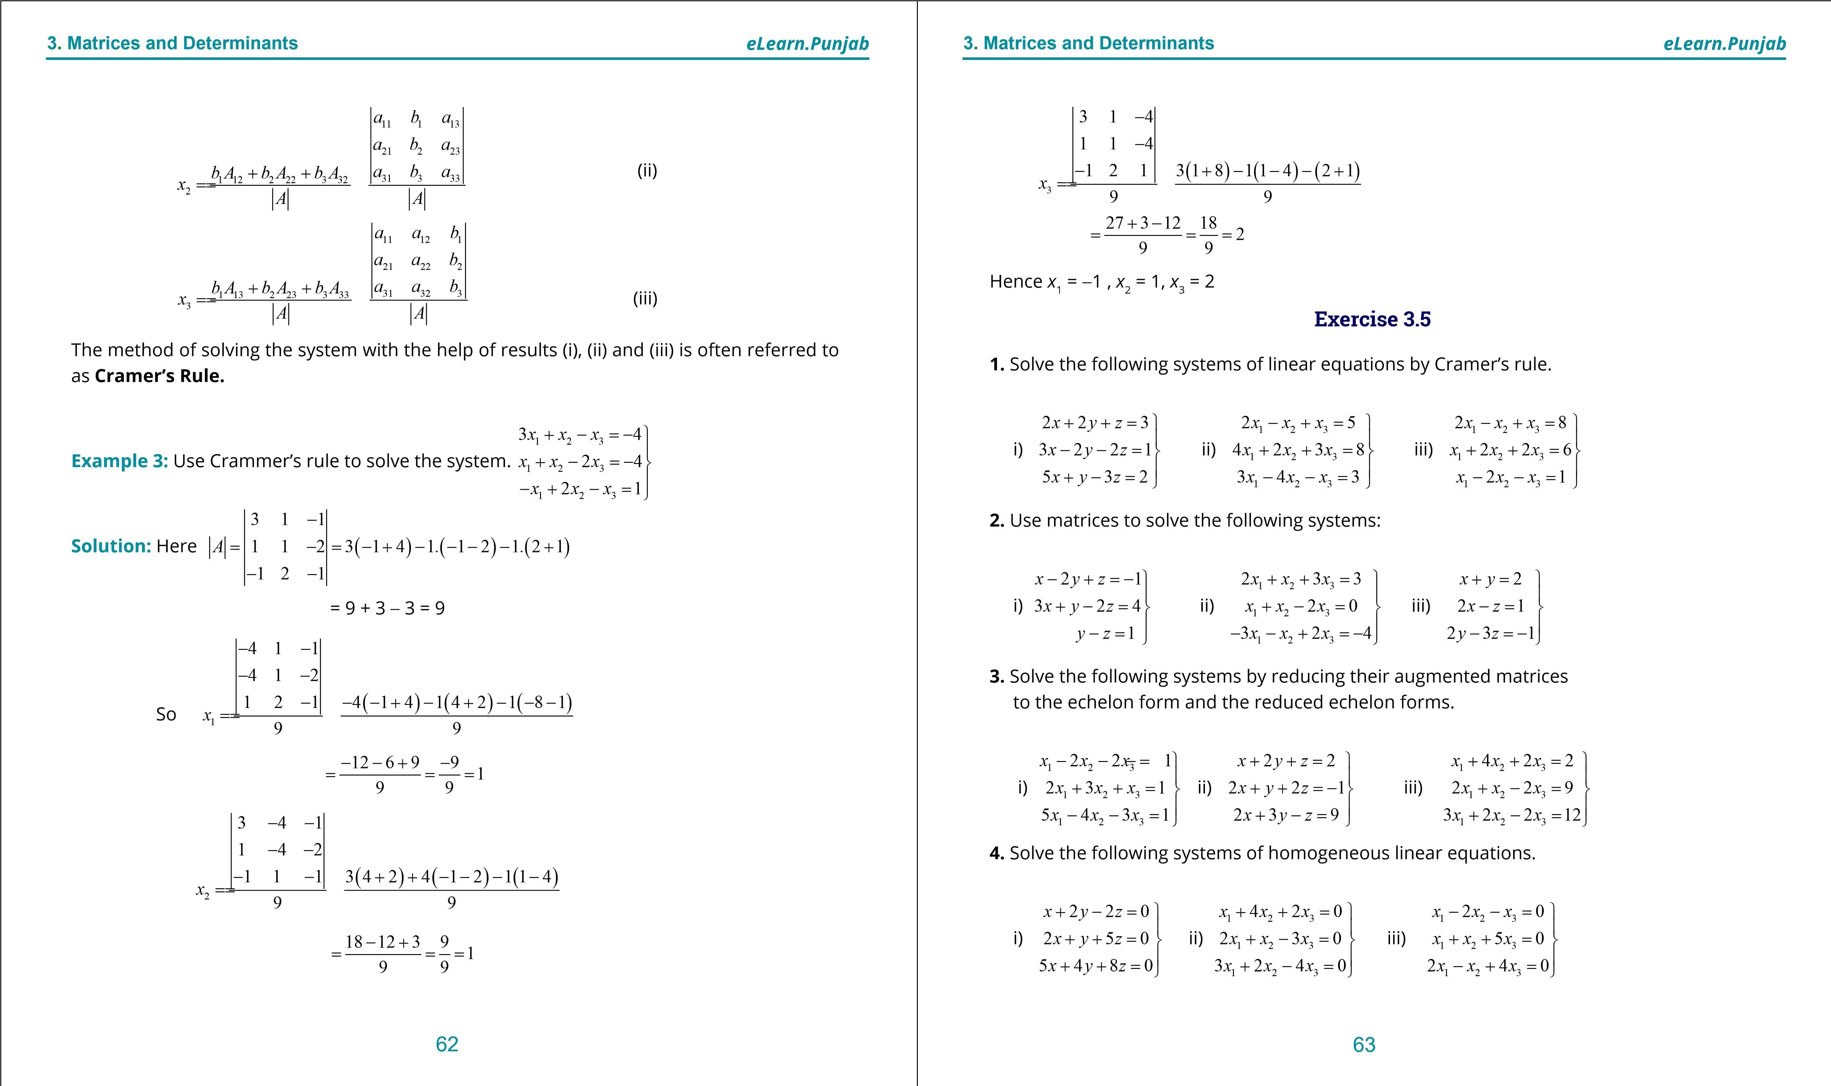

***version: 1.1***

**. Quadratic Equations**

**1**

**eLearn.Punjab**

**3**

**.**

**Matrices**

**and**

**Determinants**

***eLearn.Punjab***

64

**5.**

Find the value of

λ

for which the following systems have non-trivial solutions. Also solve

the system for the value of

λ

.

i)

0

0

2

2

0

2

*z*

*x*

*y*

*z*

*x*

*y*

*y*

*z*

*x*

λ

+

=

+





=

-

+





+

=

-



ii)

1

2

3

1

2

3

2

1

3

4

0

3

0

2

4

0

3

*x*

*x*

*x*

*x*

*x*

*x*

*x*

*x*

*x*

λ

λ

=

+

+





+

-

=





+

-

=



**6.**

Find the value of

λ

for which the following system does not possessa unique solution.

Also solve the system for the value of

λ

.

1

2

3

2

1

3

3

2

1

4

2

2

11

2

3

2

2

16

*x*

*x*

*x*

*x*

*x*

*x*

*x*

*x*

*x*

λ

+

+

=





-

+

=





+

-

=



CHAPTER 4 Quadratic Equations

*Animation 4.1:* [*Completing the square*](http://1ucasvb.tumblr.com/post/42739093986/completing-the-square) *Source & Credit:* [*1ucasvb*](http://1ucasvb.tumblr.com/)

